HungaroLogo konferencia
2011

XV. nemzeti konferencia
a Logo programnyelvről, a logo-pedagógiáról

konferencia kiadvány

ISBN 978-615-5036-05-7

Tartalom

Beszámoló a XV. HungaroLogo konferenciáról 3
Logo: A Turtle Tragedy in Three Acts 6
ICT and LEGO lessons in primary school – learning through creating 16
An Elica Logo Perspective on Educational Serious Games 31
A logo-pedagógia játékai 41
Maurer rózsák 47

Beszámoló a XV. HungaroLogo konferenciáról
A Neumann János Számítógép-tudományi Társaság MicroWorlds Logo Szakosztálya immáron tizenötödik alkalommal rendezte meg a HungaroLogo konferenciát, 2011. június 9-én az Óbudai Egyetem Neumann János Informatikai Karán, a Bécsi út 96/b épületének F09 termében. A Logo programnyelvvel és a Logo-pedagógiával foglalkozó szakemberek tanácskozását Nádai László, a Kar dékánja nyitotta meg, majd Csink László egyetemi docens, levezető elnök köszöntötte a megjelent résztvevőket: informatika tanárokat, egyetemi oktatókat, egyetemi hallgatókat és középiskolai diákokat. Elsőként Kovács Győző, a Corvinus Egyetem díszdoktora, az MWL Szakosztály tiszteletbeli elnöke osztotta meg velünk a Logo magyarországi történetével kapcsolatos személyes élményeit, többek közt Seymour Papert-tel való találkozásáról és munkakapcsolatáról.
A hazai tanácskozáson a korábbi években is rendszeresen részt vettek a szakma neves külföldi képviselői. Így például a HungaroLogon mutatták be először hazánkban a népszerű Comenius Logot. Többször volt meghívott előadónk Gerald Futschek Logo-szakértő, az Osztrák Számítógép-tudományi Társaság egyik vezetője, avagy a Szófiai Egyetem Matematika Karán oktató Pavel Boytchev. Nagy örömünkre, idén három külföldi előadót hallgathattunk meg angol nyelven. Elsőként Mike Philip Doyle (Egyesült Királyság), az EuroLogo konferenciasorozat alapítójának Prefrontális kapcsolatok című előadása győzött meg minket arról, hogy a teknőc-geometria alkalmazása milyen fontos szerepet játszik a képességfejlesztésben, szövegeinek kezelése pedig az általános iskolában az írásbeliség elsajátításának hatékony segítője.
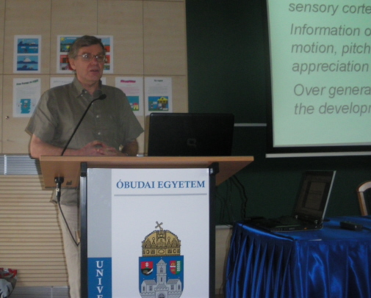
Mike Doyle előadása. A háttérben bolgár gyermekmunkákból válogatott képek

Vessela Iliana bolgár informatika tanárnő egy szófiai általános iskolában tanít, Bulgáriában az informatika kötelező tantárgy. Előadásában sok-sok fotóval és filmrészlettel illusztrálta a 7-11 éves tanulók tevékenységét. Az iskola komoly LEGO-DACTA készlettel rendelkezik, amelynek mozgó, fényt és hangot adó elemeit, járműveit a Logo segítségével programozzák. Az informatikaórák projektszervezésűek, több órán, több héten keresztül épül fel egy-egy LEGO-városka, ahol az egyes aktuális események, ünnepek (pl. karácsonyi vásár, diszkó, vidámpark) is modellezésre kerülnek, természetesen a programozási és építési feladatokban a diákok mindegyike önálló feladatot is kap.
Pavel Boytchev, a szófiai egyetem tanára már többször elkápráztatta hallgatóit: legutóbb a 2010-es párizsi Constructionism konferencián (ennek beszámolóját ld. a Mi Újság 2010. szeptemberi számában, ill. online: http://njszt.hu/sites/default/files/mi_ujsag_2010_szeptember.pdf). Előadásában láthattuk a Logo „családfáját”, a jelenlegi 248 Logo-változattal. Boytchev az 1999-ben született, általa életre hívott és azóta folyamatosan fejlesztett Elica 3D-s Logo-implementációt használja egyetemi szinten: a 3D tervezésben, a topológia, a csillagászat, a gépészet stb. tanításában, illusztrálásában. Előadásában számos animáció részletét láthattuk a kúpszeletek szemléltetésétől kezdve a földrengés-szimulációkon át a naprendszer mozgásáig. Érdekes a Pitagorasz-tételt, Dandelin-gömböket és egyéb térgeometriai alakzatokat bemutató filmje a youtube-on: http://www.youtube.com/watch?v=1v5Aqo6PaFw, de a lenyűgöző látványt a fraktálok, Mandelbrot-ábrák művészi megjelenítése adta a hallgatóság részére, bizonyítva az Elica-Logo magas-szintű alkalmazását: http://www.youtube.com/watch?v=93akxnQ1xxw&feature=related. Az Elica csoport munkásságára az interneten is rákereshetünk.
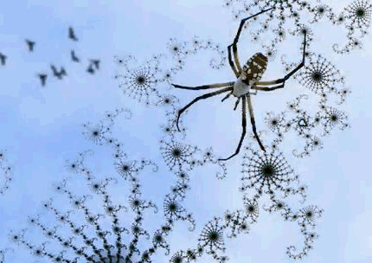
Részlet Boytchev Seduction (Csábítás) c. kisfilmjéből
A hazai előadók a Logo oktatási alkalmazásainak különféle aspektusait idézték fel. Kőrösné Mikis Márta, az ISZE elnöke A Logo-pedagógia játékai címmel tartott előadást, amelyben – a játék tanulási folyamatban betöltött, nélkülözhetetlen szerepét hangsúlyozva – a hazai óvodák és iskolák Logo-hoz kötődő játékait csoportosította, sok-sok képpel illusztrálva. A JIO, majd a Gyermekinformatika Szakmai Műhely pedagógusai által kitalált és egyre bővülő játékkínálat a teknőcöt személyesíti meg, akár számítógéppel, akár anélkül.
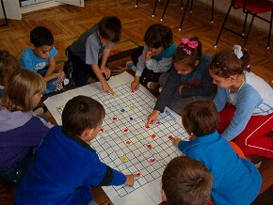
Logo-előkészítő teknőcjáték informatika órán
Egyetemi hallgatók, főiskolások már többször szerepeltek a Hungarologo konferenciákon, ám idén először adott elő – még némi lámpalázzal – középiskolás diák. Csizmazia Tomor Ferenc (Nemes Nagy Ágnes Humán Szakközépiskola) a Logo-t megismerve és megszeretve arra vállalkozott, hogy a székely-magyar rovásírás betűit a latin betűknek megfelelteti.
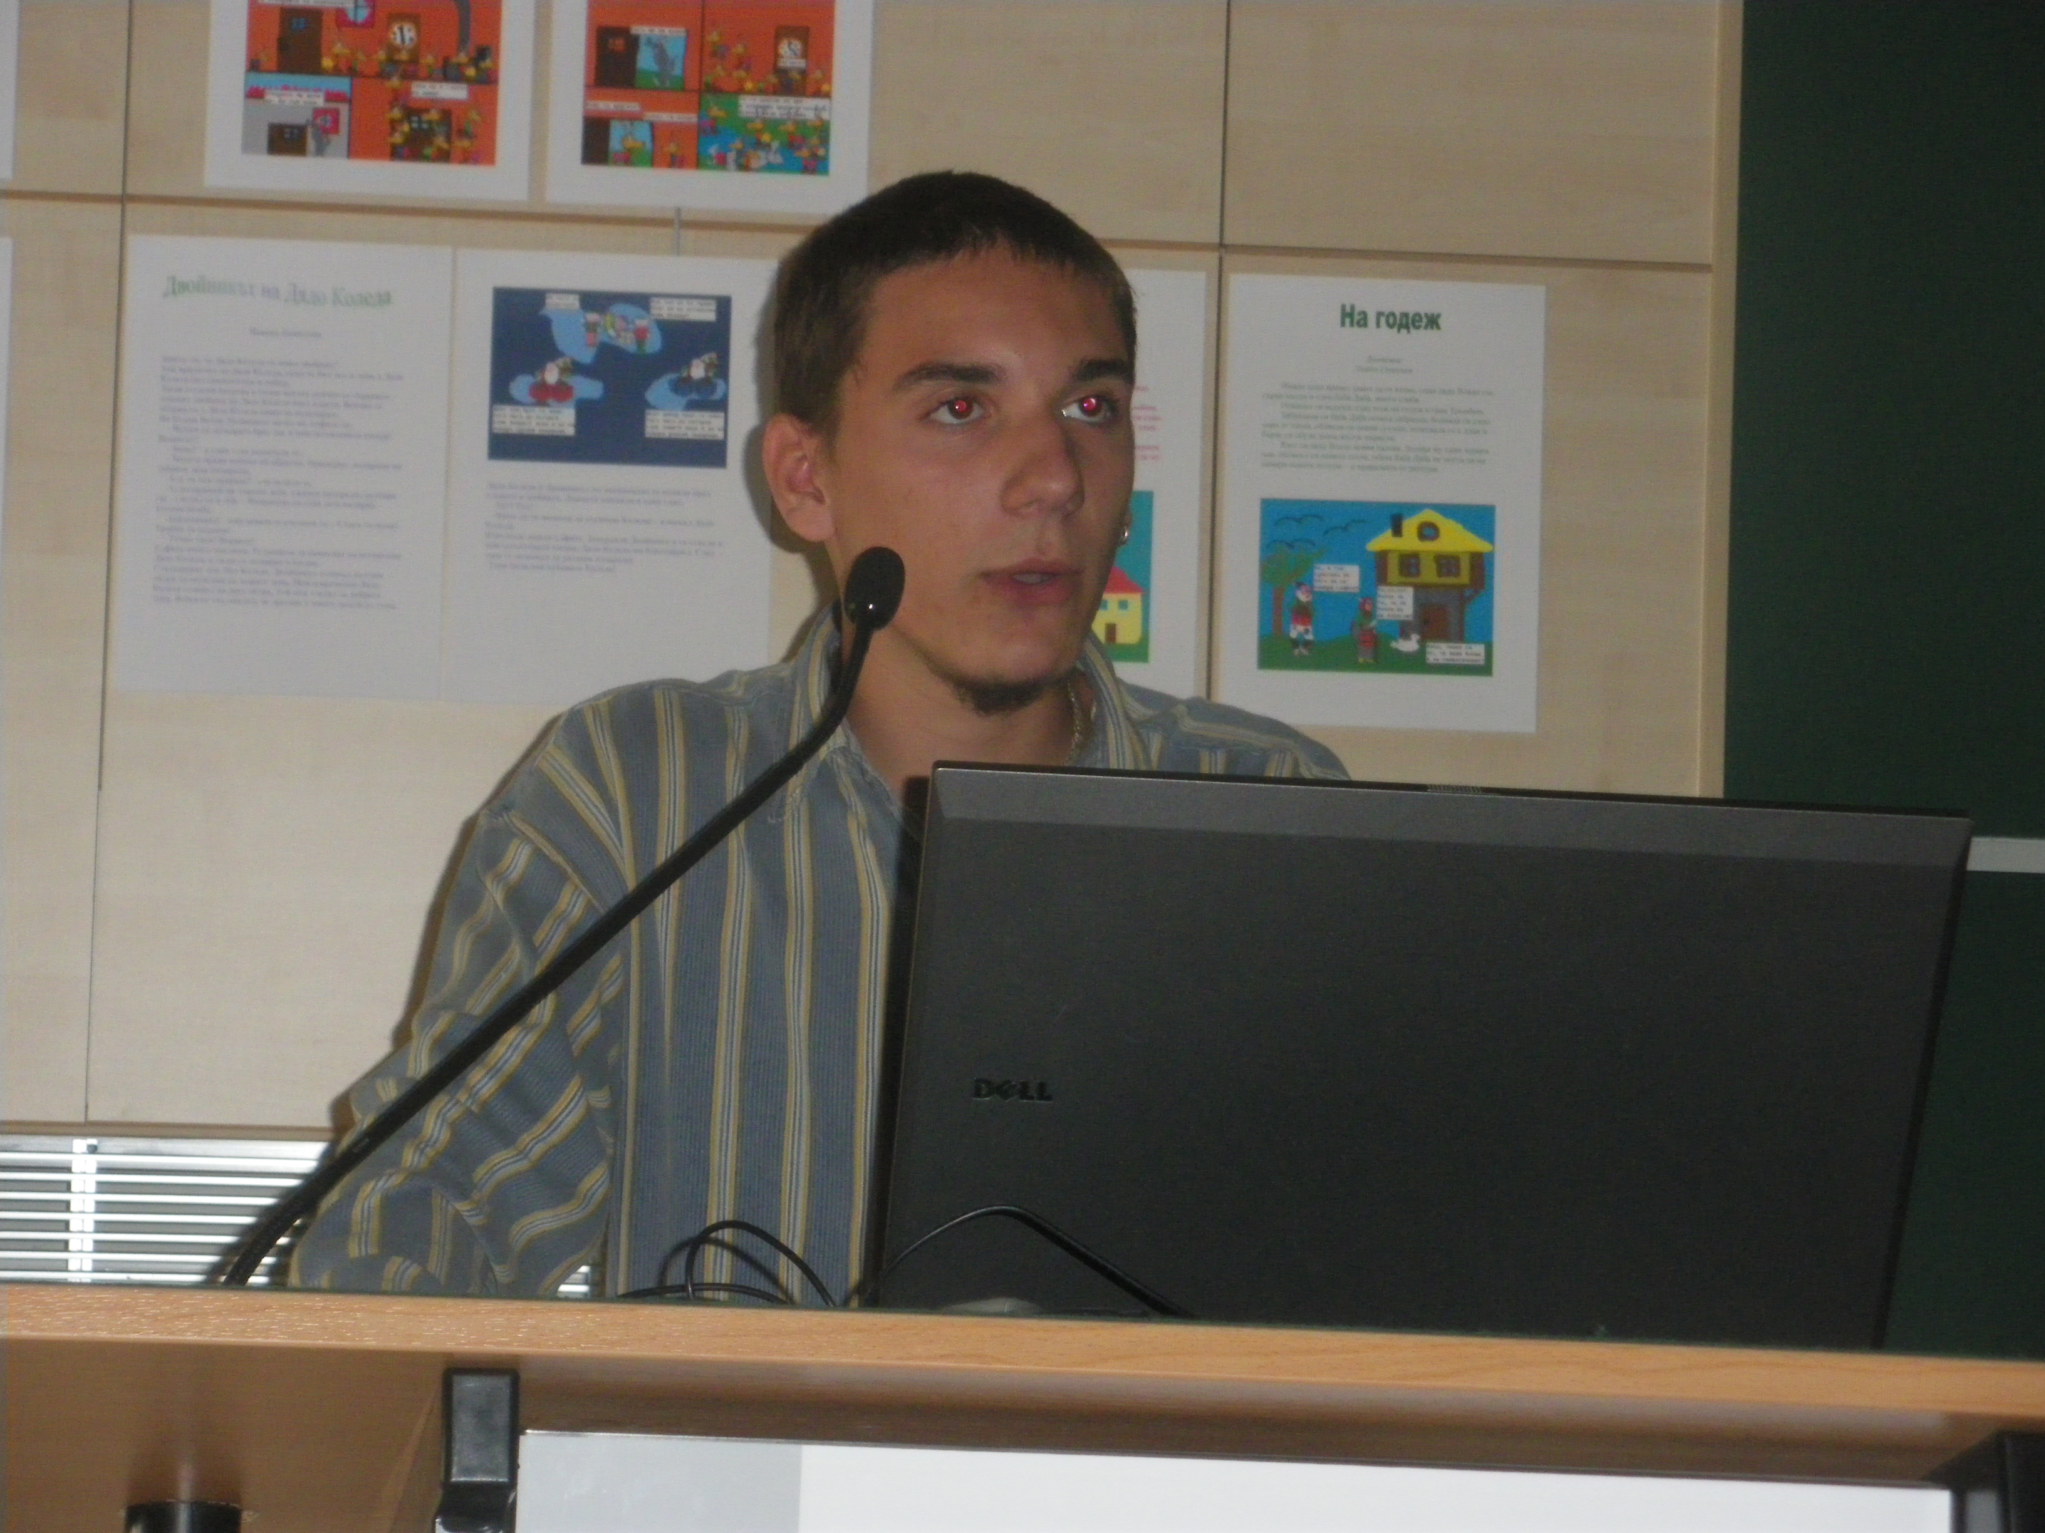
Ők a számítógépes generáció
A teknőc tehát a klaviatúrán leütött betű hatására azonnal kirajzolja annak rovásírásos megfelelőjét, azaz lehetőség van arra is, hogy egész szövegeket „fordítsunk” le erre a régi írásmódra. A diák munkáját szakosztályunk tagja, Oláh Anna tanárnő segíti, informatika tanára Tasnádi Ildikó. A hallgatóság soraiban résztvevő Borbély Endre, az Óbudai Egyetem docense az értékes munkát látva felajánlotta közbenjárását, hogy Ferenc részt vehessen és bemutatkozhasson idén nyáron a Magyarok Világtalálkozóján is, Balatonlellén.
A záró előadást Farkas Károly tartotta Maurer rózsák címmel. Ezek a látványos virágminták több teknőc szuperpozíciójával is előállíthatók, a Logo-ban lényegesen egyszerűbben, mint bármely más módon. Ez egy újabb példája a „paradicsomi mikrovilág” (Káin végrehajtja úgy Ádám mind Éva mozgáselemeit) hatékony alkalmazásának. A Maurer rózsák esetében a szereplők adatokat cserélnek egymás között, és így rajzolják ki a rózsát és annak feszítő görbéjét.
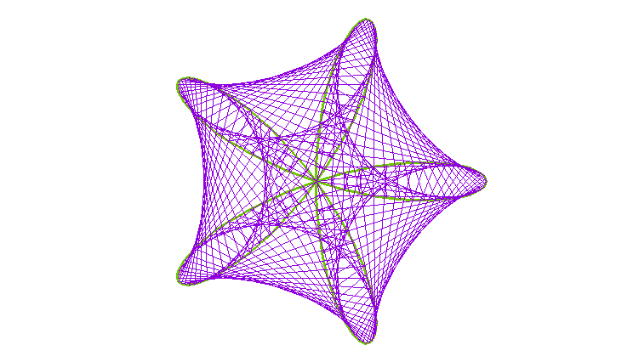
Maurer rózsa, és feszítőgörbéje 5 és 97 paraméterekkel
A konferencia – és egyúttal a Logo – töretlen sikerét a zárszóban elhangzó újabb ötletek is jelzik. Tovább erősítjük kapcsolatainkat a határon túli, Logo-pedagógia iránt érdeklő iskolákkal, a projekt vezetője Kovács Győző. A Szakosztály képviselői tavaly az erdélyi Csíkszeredán, Erdőszentgyörgyön, Kolozsváron és Szamosújváron, a bácskai Újvidéken, idén pedig Beregszászon tartottak bemutatót, további terveink között pedig Zenta és Topolya szerepel. Kovács Győző bejelentette, hogy a következő Neumann Programozói Versenyen külön Logo-kategóriát is hirdetünk, és igen nagy újdonság, hogy a résztvevők alsó korhatárát pedig 6 éves kor alá csökkentjük!
Kőrösné Mikis Márta - Farkas Károly

Logo: A Turtle Tragedy in Three Acts
Micheál Ó Dúill
Logios.org
(logios.org@googlemail.com)

Prologue
Just before the outbreak of the Second World War, a young Englishman wrote a paper that tested Hilbert’s question about whether all mathematical problems were solvable algorithmically, i.e. by a mechanical process. He approached this, not through a formal mathematical system but by imagining a machine that might carry out the process.
...an infinite memory capacity obtained in the form of an infinite tape marked out into squares, on each of which a symbol could be printed. At any moment there is one symbol in the machine; it is called the scanned symbol. The machine can alter the scanned symbol and its behavior is in part determined by that symbol, but the symbols on the tape elsewhere do not affect the behavior of the machine. However, the tape can be moved back and forth through the machine, this being one of the elementary operations of the machine. Any symbol on the tape may therefore eventually have an innings.
(Turing 1948, p. 61)
Turing's machine, a piece of ‘thought’ engineering that describes a [stored program digital] computer, is the mathematical equivalent of the lambda calculus that Alonzo Church used in his solution of Hilbert’s decidability problem; now known as the Church-Turing Thesis:
A function is said to be ‘effectively calculable’ if its values can be found by some purely mechanical process. Although it is fairly easy to get an intuitive grasp of this idea, it is nevertheless desirable to have some more definite, mathematically expressible definition. Such a definition was first given by Gödel at Princeton in 1934… These functions were described as ‘general recursive’ by Gödel…Another definition of effective calculability has been given by Church… who identifies it with lambda-definability. The author [i.e. Turing] has recently suggested a definition corresponding more closely to the intuitive idea… It was stated above that ‘a function is effectively calculable if its values can be found by a purely mechanical process.’ We may take this statement literally, understanding by a purely mechanical process one which could be carried out by a machine. It is possible to give a mathematical description, in a certain normal form, of the structures of these machines. The development of these ideas leads to the author's definition of a computable function, and to an identification of computability with effective calculability. It is not difficult, though somewhat laborious, to prove that these three definitions are equivalent.
(extract from Turing’s PhD Thesis, which was supervised by Alonzo Church)
Thus, the computer and its program came together in a single, powerful, concept. Electronic engineers developed the physical machine that could read and write and software engineers the program, although the first program ever written was composed by an engineer on his train journey home. From a Logo perspective, Church’s lambda calculus is the more immediate. Lisp, short for list-processing, was a computer language based on the lambda calculus. Logo is a derivative of Lisp designed for use in school. Programs run on an electronic machine that is the formal equivalent of the Turing mechanism. The mechanism – which might be a human brain (a computer was originally a person) – is the more powerful concept. The relationship of the mechanical device to the human brain remains an unresolved issue. However, the greater issue is the question concerning technology itself: How might a biological organism conceive a mechanism that is non-biological? This issue is explored in The Technicity Thesis: It concludes that the mechanism is more ‘powerful’ than the symbols.
Next year, 2012, is the 100th anniversary of Turing’s birth – so now is an apposite moment to reflect on the conceptual machine that, in 1948, became a real machine, is now an ever-day commodity, and for which Logo and the Turtle were devised for the education of children.
Act the First: in the beginning
Logo was designed to help children learn mathematics. It did. But then, very many educational experiments that later fade had an initial positive outcome. Indeed, on reflection, is it not a little perverse to use a machine that can read, write, and, with a little instruction, do arithmetic, to teach the subject according to an extant curriculum and assessment targets? However, in the late 1960s, when Logo was first developed, the focus was (and still remains today) on how computers could help children better to learn the existing curriculum. Nevertheless, Seymour Papert, a student of Jean Piaget and the author constructionism, an extension of Piaget’s constructivism, believed that the activity of programming was valuable of itself.
At this time, remote terminal, time-sharing mainframe computers with text input and output were the latest technology. The first experiments took place within the first year of the secondary phase. Text-based input/output posed the question of how to make computing power accessible to all children of primary school age. The solution was the floor turtle: a device inspired by Grey-Walter’s tortoise (machina speculatrix) and initially controlled from a button box. The first Turtle had a touch sensor that operated a sound device. The commands of turtle graphics (forward, back, left and right) were added to Logo in order to control this device. In addition, it was given a pen to draw a trace of its path. Thus, initially children controlled a machine.
A decade later, the microprocessor catalyzed a transformation of computing. The microcomputer came to school. The results from more than ten years of research by MIT staff and students were distilled into two influential books: Mindstorms by Seymour Papert, and Turtle Geometry by Hal Abelson and Andy diSessa. Both works majored on the Turtle as a means of teaching mathematical ideas. Papert focussed on “mathetic” thinking whilst Abelson and diSessa systematically developed the idea of turtle graphics into a novel approach to geometry. A trilogy, Computer Science Logo Style, by Brian Harvey retained the original non-turtle focus of the language. Papert’s book was aimed at school and the teaching of young children in particular. Abelson and diSessa’s work was an academic textbook; an exploration of the new geometry, which they described as “local” in comparison with Cartesian and Euclidean forms. Harvey’s work was designed to introduce computer science to non-specialist students.

Act the Second: in school
In the 1980s the new microcomputers came to school – one per school initially – and the Turtle accompanied it. Seldom a physical turtle, the graphics commands were directed either at an arrowhead on the screen or embodied in a toy called BigTrak. The Logo programming language itself was not available on the first microcomputers. It is a memory-hungry language that stretched their. BASIC did not. Consequently, implementations of what Papert called “Turtle Talk” written in BASIC (for which the Abelson and diSessa provided the code, remarking that their notation was close to Logo) flooded the school market. Given the popularity Mindstorms, the intellectual respectability of Logo, and Papert’s focus on the Turtle, these software packages were promoted as “a subset of Logo” as opposed to “an implementation of turtle graphics”. Commerce, not renowned for its respect for terminological exactitude, used “Logo” as a sales strategy. The consequence, in the England at least, was that the legal definition of Logo became “the turtle graphics”. Thus, many in education used a package that had no direct link to the Logo programming language under the misapprehension that it was. And, given the mathematical focus on turtle geometry, there was debate about whether Logo was actually necessary whilst some educationalists argued that the turtle notation did offer an introduction to the style and syntax of Logo proper.
In the dark recesses of the early research using the Turtle, there lurked an artefact; an effect that had been talked away rather than reflected upon. Noted and considered in both Mindstorms and Turtle Geometry, it was an mistake in thinking of a specific type that came to be called a “bug” in analogy with a bug in a computer program: in this case, a bug in thinking (Turing used the word mistake). The three examples give, in order, are: the triangle, house and man bugs. They are as follows:
 | Triangle | House | Man
Target | 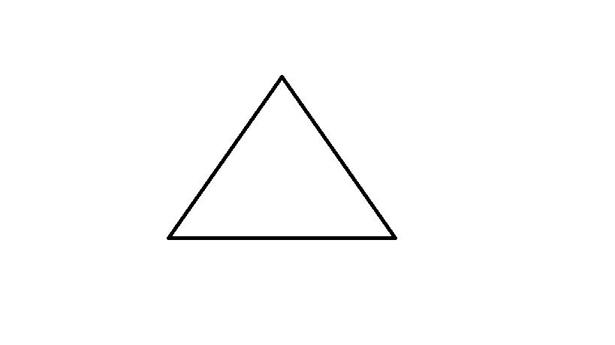
Outcome
Explanation | Thinking about the internal angle of the shape rather than the “heading” of the Turtle | Failure to realise that an “interface” procedure is needed to place the Turtle in the right state to draw. | Solved by breaking the drawing into procedures for the parts and then combining them, but see house bug.

The explanations seem reasonable and have an authentic mathematical and computer science feel to them. The suggested general solution was to “play turtle” to get the hang of heading. Many teachers tried this with children moving paper arrowheads in different orientations. Papert went further and proposed that if children “Walked Turtle” a cognitive phenomenon that he called “body syntonicity” would lead to the internalising of the concept of heading and the ability to describe shapes in “Turtle Talk”. However, experience in the primary school classroom with turtle graphics suggested that these phenomena signalled a problem of greater cognitive depth. Certainly, teachers who tried to introduce the beginnings of programming found that drawing shapes with the Turtle seemed not to be an easy entry point. Classrooms were full of simple tracks, paths and mazes that reduced the turn command to a right angle.
A final feature of turtle geometry that should have signalled concern was that the drawing produced on the screen was as dead a mark as that made by pencil on paper: there was no linking of mark and mechanism, as in Euclidean geometry. The Plane Geometry System (now developed into Elica) remedied this by making lines objects. The demonstration of drawing mechanisms implemented in Elica presented at HungaroLogo 2011 by Pavel Boychev, clearly demonstrated the mechanical deficit of turtle graphics. It also demonstrated the computational character of turtle geometry: the Turtle (visualised as two circles on an axel) cannot draw any shape other than a straight line unless it is given instructions. I.e. it is a computational object that can move only according to a program. The geometry must be known to the programmer.
Programming in turtle geometry is a means of expressing knowledge rather than acquiring it. It is sophisticated and useful, but not at primary school level: too many concepts that are not yet taught are needed for its reflective application. It is here that The Technicity Thesis (below) can offer clarity. Concepts of shape and motion (navigation) are separately sourced mentally: the former from line-detector and the latter from motion-detector neurones. Thus, the developing child will learn separately to conceive shape and movement. Therefore, to use the drawing of a shape by a set of motion commands as an entry point to programming is inappropriate from a child development perspective. This is why experienced teachers used the Turtle as an object to navigate around an environment and avoided drawing shapes.
There were other entry points to Logo programming, but none had the kudos that its association with mathematics gave the Turtle. The floor Turtle has vanished, although relatives of BigTrack continue as simple floor robots that can move on a chequerboard; cf. the original button box. Thus, in technology lessons, programming did continue but not as part of a coherent curriculum. A brave attempt at extricating Logo from the clutches of the Turtle was made when LogoWriter applied computing to word processing just as this technology was reaching the classroom. However, as with the Turtle, this microworld added an extra layer of learning when the curriculum was clearly about mastering written natural language. The LEGO/Logo microworld developed the machine control aspect of the original cybernetic tortoise. Construction of the model and the description the mechanical elements, lights, motors and sensors actually did led naturally to the program. There are still old computers in school today that run versions of technical control Logo for this specific purpose. However, as with the Turtle, the full capability of Logo was rarely exploited and simple software, like the original LEGOLines, was more likely to be used.
With all these unresolved issues, it cannot be a surprise that by the start of the new millennium enthusiasm for turtle geometry had faded, and with it Logo.
Act the Third: assimilation
By the time the twenty-first century approached, the computer had metamorphosed into a multimedia machine with internet connection. Implementations of Logo were developed to take advantage of these new capabilities. Microworlds and Comenius Logo were two object oriented responses. Both included non-turtle graphics and painting facilities as well as word processing. The latter was programmable as were the multimedia features. Comenius Logo, later to develop into Imagine, incorporated graphics as first class objects. It also offered the possibility of generating stand-alone programs. One outcome of this was ToolKID, a suite of 48 small programs written in Logo to support children in learning to use the full range of computer capabilities in the first two years of primary school in Bulgaria.
However, the graphic capabilities of the computer had a significant impact on Logo. The curriculum of primary school, in particular, has changed little over the past three decades. Although children are now expected be introduced to the capabilities of “information and communication technology” (ICT), often elided to “technology,” there is no requirement in any education system for children for children to be taught computing. Rather, the emphasis is on integrating (assimilating) the new technologies to traditional educational objectives and curricula. This is reflected in the ongoing debate over whether primary school children should: a) be systematically taught to use all the capabilities of the computer in the context of normal activities for their age in a computer room by a teacher who is a trained master of the medium; or b) pick up computer skills by using the classroom computers as and when their use is appropriate to enhance the learning experience. In neither context is ‘computing’ per se an explicit part of the curriculum: a state of affairs that has catalysed an inquiry into computing in schools by the English Royal Society under the Chairmanship of the designer of the ARM processor, which is now embedded in many devices including smart-phones.
The decline of Logo is reflected in the lack of recent development activity in the two major commercial implementations and its attempted replacement by graphic programming environments such a Scratch for introducing computer science concepts and LabView for controlling LEGO constructions – both activities now seen as a part of the STEM agenda. This change in fortune was reflected, in 2010, when the biennial Eurologo Conference was renamed “Constructionism” to reflect Papert’s belief that the activity of constructing an “object open to public inspection” is at the heart of learning. This, arguably, has more general educational import than the programming language per se. It is in tune with The Technicity Thesis in that it privileges human constructive capability over language. Therefore, as the curtain falls on the third act of Logo, the original objective of the programming language: giving children assess to and experience of, arguably, the greatest intellectual achievement of our species, has not been achieved. This does not mean that children do not absorb the qualities and possibilities of this technology. They are born into a world where it exists and is, for them, not new; just a part of the world they will learn to live with and exploit.
However, education is an enterprise that goes beyond the purely utilitarian. It needs to offer to children the possibility of standing on the shoulders of their forebears to take knowledge forward. So, before the fire curtain descends to signal the closure of the theatre, there ought to be an epilogue.

Epilogue
Reflection on the Turtle must begin with the recognition that the Turing machine, the conceptual hardware, is more powerful than its counterpart the lambda calculus. We may liken the Turing machine concept to the heat engine of the Carnot cycle. The heat engine is a mental mechanism that may be physically realised and which leads to the second law of thermodynamics. The Turing machine is similarly realisable and leads to the concept of computability. In physics there is a truth not present in mathematics. Theory must be tested against the physical world. There is a fine distinction between the mental machines theories that are expressed in the words of language. The brake on constructive thinking about this relationship is twofold: firstly, lack of knowledge about how humans come to be able to create technology; and secondly, a presumption that language is our highest cognitive capability.
Information/entropy considerations reveal the true relationship: a biological adaptation for verbal communication is less powerful than technology that is beyond the bounds imposed by biological processes. Papert’s constructionism begs the question of why ‘making things’ is more powerful than ‘discourse’ about matters in mind. The Technicity Thesis remedies this by identifying an information source within the nervous system that enables the human brain to operate beyond the bounds of biology. The source is the expression of genetically encoded information about the internal structure of the universe in primary sensory cortex. This includes information on the electromagnetic spectrum, which is not detected at the eye; for example, what we perceive as the colour yellow. A difficult concept to grasp, it has great explanatory value. For instance, it explains the Platonic ideal of colour by identifying a referent that is independent of sensation. Other such ‘conceptual’ information includes line length and angle, speed and direction of motion, and pitch. The human alone amongst animals has access to this information. Everything that flows from this unique, strictly biological, adaptation is technology. Writing is technology; mathematical notation is technology; the computer is technology. Technology takes thought beyond the bonds of biology that eventually overcame our Neanderthal cousins. It triggered the third transition in the evolution of the universe; the first two being from energy to matter and matter to life. Papert’s concern with mathematics, the ‘mathetic’ concept, in its turn influenced by a culture that revered the lambda calculus over the Turing machine, led to a neglect of the true nature of technology. Platonists knew better. In inscribing “let no-one ignorant of geometry enter” above the Academy threshold they denied the primacy of language and the biology-bound thought that flows from it.
We may now prepare a critique of the Turtle. Information at the foundation of technology, which also conforms to the notion of a Platonic ideal form, comes from discrete sources and represents specific features in the sensory input stream. Two of these are: a) line length and orientation; and b) direction of motion. When we think of Euclidian plane geometry construction we use a mental straightedge and compass. Cartesian geometry places an artist’s grid over the construction and describes it with coordinates. These are mechanical procedures and the mechanisms know nothing of the construction: that is the province of the human mind. The Turtle is very different. It is a computational object. Pavel Boychev’s demonstration of a Turtle (reduced to two circles on an axle) makes clear that it must ‘know’ the form it will describe. Like a Newtonian object, it intrinsically knows only about motion in a straight line and has to be told to turn in a specific direction.
Now let us consider our Turtle “bugs,” in order. First, consider the internal information available. Our motion detectors allow us to see that a car is passing our window and a bus is travelling the opposite way. These are the feature detectors that enable us to navigate. However, this information maps poorly to language: try asking for directions. Line length and angle features are the source of our ability to imagine ideal forms, such as a square. A square is composed with information sourced from detectors that react to lines orthogonal to each other. We can, therefore, visualise a perfect square; and again it maps poorly to language. Therefore, Turtle movement and shape construction employ different sources of information insulated from each other. Given that the navigational nature of the motion feature, which tends to be verbalised in terms of “towards” some landmark and be measured by time (a day’s walk) rather than distance (paces), the only way to get a good notion of the path for a shape is to mentally run the Turtle around the shape. (The tendency to fail to return the Turtle to its original heading after drawing a shape leads to the ‘total turtle trip” theorem.) It follows that shape understanding precedes and is prerequisite for the construction of a set of Turtle commands for any shape. The tendency is to draw a square first, where internal angle and angle of turn are numerically indistinguishable. The mental process of running the Turtle round a triangle, where Gestalts bring to mind the internal angle, leads naturally to the triangle bug; particularly where the human programmer knows about internal angles and the 360 degree division of a circle. As the authors of Turtle Geometry pointed out, this bug is easily dealt with – but not by playing Turtle, rather by mentally projecting the Turtle line of motion and turning from it, as one does when driving a car.
The house bug is more interesting. Children have no difficulty at all in placing a triangle on a square to make a house-like shape – even if they then proceed to draw a chimney orthogonal to the roof. Here, again, differing information sources are the source of the problem. The triangle and square are two ideal forms. For a house they can be composed into a visualised unit for the hand to draw. The path of the pencil need not follow the computational model of square procedure followed by triangle procedure. Indeed, most children will draw two converging lines from the top corners of the square. The turtle graphic task of getting the Turtle from its home position after drawing a square to the correct position and orientation to draw the triangle is not easily visualizable as there is no shape mentally to trace. Thus, determining and expressing the so-called interface procedure is a non-trivial task. The analogy of a computer programmer interfacing two library procedures is not valid.
The man bug, allegedly solved by breaking a long string of commands into separate procedures would suffer from the same “where is the Turtle?” interface problem. The illustration demonstrates the difficulty humans have in remembering a set of directions or deriving them from a map: the cognitive visual-to-language linkage problem.
Finally, for all Turtle activities, realisation that the Turtle must have ‘in mind’ exactly what it is anticipated to carry out is required. This means that the child must bring into play theory of mind in order to imagine what the Turtle thinks. This is a capability that begins to develop from about the age of four and is not complete until the end of the primary school phase.
These multiple cognitive layers mean that the Turtle cannot offer an easy way into programming and that the superficial simplicity of Turtle geometry is an illusion. It is, therefore, of no surprise that primary school teachers, with an expert knowledge of children’s developing cognitive maturity, stuck to simple maze exercises with only orthogonal turns. In truth, the Turtle is a sophisticated academic conceit that should never have been promoted for drawing shapes by young children. On the other hand, non-shape-based activities, like navigating the Turtle around a village, is a suitable activity – provided the children are provided with a protractor to estimate the angle of turn and a measure the determine distance. With a suitable curriculum and teaching method to scaffold their learning, the Turtle may significantly contribute to children’s understanding of the nature of the computer as a medium and its new capability as an instrument that, like them, to have something in mind.
Let us think more constructively about the place of Logo in the educational panoply. Consider the following viewpoint, which is common to much discussion about the computer. It opens the preface of Turtle Geometry:
Five centuries ago the printing press sparked a radical reshaping of the nature of education. By bringing the master’s words to those who could not hear the master’s voice, the technology of printing dissolved the notion that education must be reserved for those with the means to hire personal tutors. Today we are approaching a new technological revolution, one whose impact on education may be as far-reaching as that of the printing press: the emergence of powerful computers that are sufficiently inexpensive to be used by students for learning, play, and exploration. It is our hope that these powerful but simple tools for creating and exploring richly interactive environments will dissolve the barriers to the production of knowledge as the printing press dissolved barriers to its transmission.
Three decades on, the internet is in the process of fully removing the barrier to transmission of knowledge that the printing press began. But we must argue with the underlying concept of the computer, its authorship notwithstanding. The progression from meaningful marks to printing to the internet is linear. There is no fundamental difference between them: they are all technologies of writing, of record, that must be explored by a human mind. Forty years on and with the hindsight that The Technicity Thesis offers we may take a very different view of the computer. The “simple tools” are now to be perceived as a medium that has a very different relationship to thought than does a mere medium of record. The programmed computer, the Turing medium, can scaffold mental processes in a way that text never could. Education can never be the same again. This is why thinking in terms of a Turing medium is so important. We may now safely place technology above language where matters of intellectual power are concerned. This is why the Turing machine concept is so vital: the machine can read and write but needs instruction to do arithmetic. It follows that programming, writing to place something in the computer’s mind, is intrinsic to mastery of the medium. Writing for the computer as an audience is now an aspect of literacy. In writing natural language, we do not offer children a ‘kiddie’ version to start with. They are immersed in adult text from the beginning. Only the stories are simpler. The relationship of Logo to the lambda calculus, its textual nature coupled with simple syntax and vocabulary, makes it unarguably the best language for learning the nature of the Turing medium, as Brian Harvey has shown. But children need a something concrete to write about; and that something had better be a machine. Vessela Ilieva has demonstrated in over twenty five years of classroom teaching that LEGO/Logo achieves this end. Thus, Logo ceases to be a ‘something’ to help children to learn mathematics. From kindergarten to university, it is the very stuff of human learning.
We now discover that the true tragedy of the Logo was in its implanting into a hostile environment. The Turtle had a very attractive anthropomorphism. Unfortunately, the institution was unprepared for a medium with a mind. This was exacerbated by the misconceptions with which turtle geometry was imbued and which, once it was out of the laboratory and in the hands of expert primary school teachers uninfluenced by its progenitors, were rapidly exposed. The result was that the strategy designed to help its acceptance actually increased the likelihood of rejection. The lesson to be learned is that it is not possible to integrate ICT into the existing educational infrastructure. Only those trivial aspects of computer capability that conform to traditional method will be assimilated. Transformation is required.
Institutional education is the last surviving medieval craft guild. Controlled by schoolmen, it elevates the word and denigrates the machine. The task is now to build a Turing Academy where the mechanicals of geometry take precedence over the word of the scholar – which they can bring to heel. This will be a marathon process. Turtle geometry was a false start. Logo and the Turtle, in principle, were not. Children need to write for the medium. The idea of writing software for school use in the language, as was done in Bulgaria, offers an unobtrusive and unthreatening starting point. Once present, the capabilities of the language may be introduced as small enhancements leading, eventually, to change in method. However, technological progress tends not work this way and the conservatism of the system militates against success. The author’s preference is for a separate institutional arrangement along the lines of an engineering pilot plant: implement, evaluate, prove the benefits and then scale up.
Once more, from the top
Machines are trans-biological
The Turing machine is a machine
Therefore Turing conceived a trans-biological entity
Hence, human intelligence is trans-biological
Language is biology-bound
The Turing test is language-based
Therefore the Turning test is not a test of human intelligence
The word was the end of biology not the beginning of technology
Education …

Many years ago I was asked by a university admissions tutor, “What is entropy?” my unsatisfactory answer referred to heat engines and the Carnot cycle. Today I would answer by saying that it is the fundamental property of matter that makes us human.

Bibliography
Abelson, H. and diSessa, A. (1981): Turtle Geometry: The Computer as a Medium for Exploring Mathematics. The MIT Press, Boston MA
Agalianos, A. Whitty, G. & Noss, R. (2006): The Social Shaping of Logo. Social Studies of Science April 2006 36: 241-267 (downloadable pdf at: citeseerx.ist.psu.edu/viewdoc/download?doi=10.1.1.108.7948.pdf)
Boychev, P. C. (1999): Elica Logo and Objects, Proc. of the 7th European Logo Conference EUROLOGO '99 Sofia, Bulgaria, 160-168. (Downloadable from: http://www.elica.net/download/papers/ElicaLogoObjects.pdf)
Dunbar, R. (2004b): The Human Story. Faber & Faber, London.
Finlayson, C. (2010): Humans Who Went Extinct: Why Neanderthals died out and we survived. Oxford University Press, Oxford.
Fuster, J.M. (2008): The Prefrontal Cortex. Fourth Edition, Academic Press, London.
Harel, I. and Papert, S. (1991) Constructionism. Ablex Publishing Corporation, Norwood NJ.
Harvey, B. (1997): Computer Science Logo Style. 2nd Edn, Vols 1-3. The MIT Press, Boston MA. (Download from: http://www.cs.berkeley.edu/~bh/)
Heidegger, M. (1977): The Question Concerning Technology [tr. Lovitt, W.]. Harper Torchbooks, New York.
Hubel, D.H. (1995): Eye, Brain, and Vision. http://hubel.med.harvard.edu/index.html [20.07.2011]
Ilieva, V. (2010): LEGO and LOGO in the primary school – a simple way for learning through creation. In: Clayson, E. J. Kalaš, I. Eds., Proceedings of Constructionism 2010 – 12th European Logo Conference. Faculty of Mathematics, Physics and Informatics, Comenius University, Bratislava.
Ivanov, I. and Ilieva, V. (2005): ToolKID – Logo language based software package for children. In: Proceedings of EuroLogo 2005. Edited by G. Gredorczyk, A. Walat, W. Kranas, M. Borowiecki. Warsaw, August. pp. 390 − 397.
Ince, D. C. (1992): Collected Works of Alan Turing: Mechanical Intelligence. London, New Holland
Napper, D. (1998): Computer50 : The University of Manchester Celebrates the Birth of the Modern Computer. http://www.computer50.org/
Ó Dúill, M. (2010): Can there be a Science of Construction? In: Clayson, E.J., Kalaš, I, Eds. Proceedings of Constructionism 2010 – 12th European Logo Conference. Faculty of Mathematics, Physics and Informatics Comenius University, Bratislava.
Ó Dúill, M. (2011): The Technicity Thesis: De-re-constructing “Integrating ICT into education.” In: Proceedings of ELDE Conference, Sofia, Bulgaria, 6 – 8 April 2011, pp. 416-423, Demetra, Sofia.
Papert, S. (1980): Mindstorms. Harvester Press. Brighton.
Stonier, T. (1990): Information and the Internal Structure of the Universe. Springer-Verlag, London.
Turing, A. M. (1948): Intelligent Machinery. In: Ince DC, editor. Collected works of AM Turing — Mechanical Intelligence. Elsevier Science Publishers, 1992

ICT and LEGO lessons in primary school – learning through creating
Vessela Ilieva, vessela.ilieva@abv.bg
НСОУ „София” (NSOU “Sofia”) Montevideo Str. 15, Sofia, Bulgaria

Abstract
The introduction of ICT in primary school acquaints the children with the possibilities of the contemporary computer systems and the variety of their applications. It provides the acquisition of basic knowledge and practical skills of working with computer which gives the children the opportunity to use computers for accomplishing their own ideas and projects.
For that purpose the ICT education should provide:
facilities accessible, understandable and attractive to the child;
ensuring great variety of activities and permanently active role of the child in the learning process;
the opportunity to work on topics and issues of interest to the child itself and being directly related to its actual life experience;
the creation of a particular product that is valuable from the child's point of view and is able to "materialize" the invested skills and efforts.
In that context this paper deals with the use of special LOGO-based educational software and LEGO materials in the educational program in order to enrich the teaching of ICT with new meanings and as an instrument of providing a larger variety of activities in the teaching process. Using the computer as a tool for creating their own products and for managing and controlling of external objects (LEGO models, created by the children themselves) reveals more remarkable areas of its application. That is also a natural motive of introducing the children to programming in a way attractive, interesting and accessible for them. The result of programming is very attractive and devoid of abstraction. It is easy to formulate as a prior expectation and clear to describe step by step, as it concerns behaviour that the child knows from the real life.
Keywords
Primary school, ICT education, LEGO, LOGO, programming, creativity, knowledge
Introduction
In Bulgaria, a non-mandatory national curriculum for learning to work with computers in primary schools was implemented in August 1998. It was introduced as a “free elective subject.” The curriculum, in 11 modules, was written by us and had been developed within our school over the previous year (Illieva and Ivanov 1999). Its main goal was to use the capabilities of the computer as a powerful new medium to challenge children in the context of normal activities for their age. This goal is attained by a project-oriented approach that we consider fundamental to the process of education. Children implement their ideas in projects that are based on personal experience and important events in their lives. Each project leads to the accomplishment of different types of activities, which are drawn from the school curriculum. In this way the children accept an active and creative role. This is why one module was “Working with computer systems for the control of models.” It was based on my work with children and LEGO-LOGO in the primary school over the previous six years. This and other modules were optional for technical and financial reasons.
In 2006 learning to work with computers became an “obligatory elective subject” in primary school. This subject was given the name “Information Technology.” National standards were set and a new curriculum was written by a team of which we were members. Both can be found on the Ministry of Education website, http://mon.bg.
The first curriculum remains an option for primary schools as a free elective subject. So, LEGO-LOGO, which was not included the new curriculum, is still possible.
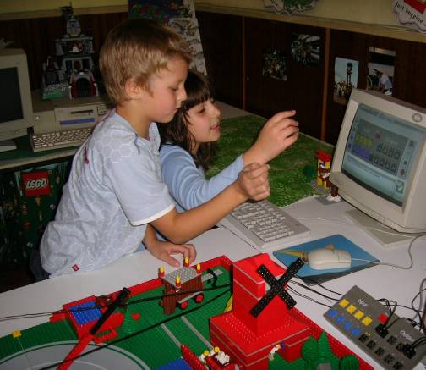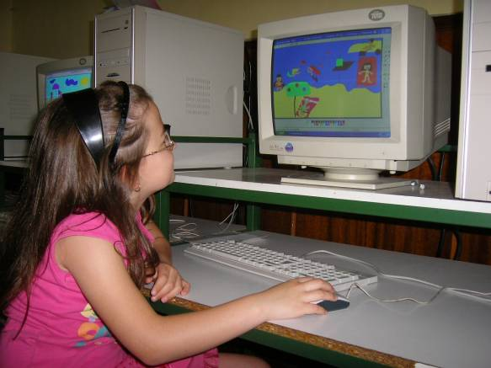
The primary school is the specific element of the system of education where the child acquires initial knowledge and skills in a diversity of areas. At the same time the child also develops basic and enduring habits, concepts and attitudes to everything studied, to the teaching itself (including the place, the people and the approach related to it) and the learning as a process of individual intellectual activity. In this sense the primary school is a fruitful territory for any kind of novelties because they are perceived spontaneously and positively by a population free of fears and prejudice. It is at the same time a dangerous territory from the point of view that this is exactly a time when bad habits and attitudes can very easily be formed and reinforced.
The introduction of new technologies in the primary school provides many opportunities; and their application can serve the achievement of various objectives. The new technologies can influence both the educational environment in its complexity and any particular process of leaning and teaching. This is regardless of whether they are introduced as an independent subject of study, or used in a specific manner within other subjects of the curriculum.
Therefore regardless of the early age, new technologies should be presented in the full diversity of their multi-functionality. By this means the child may obtain a general overall, rather than deeper but disjointed, concept of the possibilities offered by the computer as a technical means. The child will become acquainted with most of the many applications that they may later use.
Considering the specific nature of the age-group – it is demanding for any such project to provide for:
facilities accessible, understandable and attractive to the child;
a great variety of activities with a permanently active role for the child in the learning process;
the opportunity to work on topics and issues of interest to the child him or herself, which are directly related to their actual life experience;
the creation of a particular product that is valuable from the child's point of view, and that is able to "materialize" the invested skills and efforts.
Any curriculum and teaching method is only successful if the children are motivated to work well. This can only be evaluated through the quality of the products they make. Such products cannot be given a test-based grade in the way that other disciplines are. The projects themselves must be looked at for evidence of skill and knowledge in their quality. Therefore illustrations of children’s work are provided.
ICT and LEGO activities
Ever since the creation of LOGO as a programming language and a pedagogical concept, numerous and varied LOGO-based microworlds have been developed and used worldwide. The purpose of each microworld was different. They were designed to organize specific pedagogical situations where the child acts and learns by using the tools and options of the microworld. In the proceedings of the Eurologo conferences since 1987 many such microworlds are documented.
To support the curriculum and provide teachers with materials that worked well with children we created a LOGO-based software package, “Tool Kid”, containing 48 small programs/microworlds divided into 7 groups, specially designed to introduce working with the computer to young children. With their help children are learning to handle the mouse and the keyboard. They investigate the properties of the computer and use the tools necessary for the treatment of various types of information – graphics, text, sound, animation and video, individually and in combination. Development took several years including rigorous school trials (Illieva and Ivanov 2001, Ivanov and Ilieva 2005). Tool Kid was published, with teacher and student books (Illieva and Ivanov 2003-2006, Ilieva and Ivanov 2004-2007). It is used by all primary schools that teach ICT.
In the information technology classes I now teach, I use the microworlds in Tool Kid too. The key principle laid down in the creation of these programs is that in any of them the child should have appropriate environment, tools and options to act and learn, using them to solve a case or create a particular end product. The product can vary – it may be just a puzzle to solve or a picture to color, but it may be also:

A personal graphic project
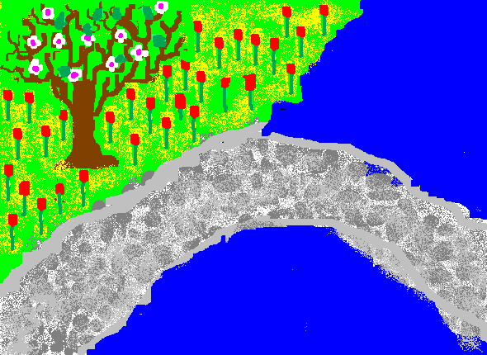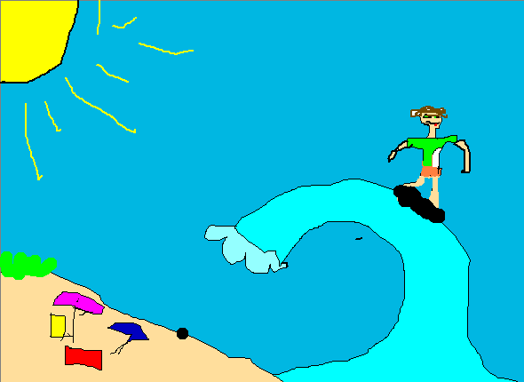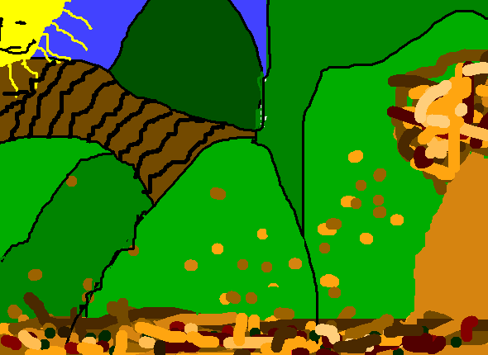
A multimedia card
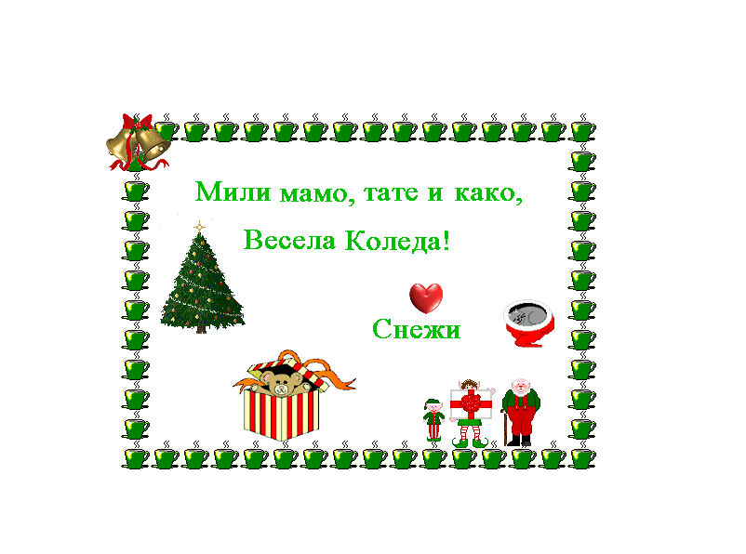
A short story with illustration
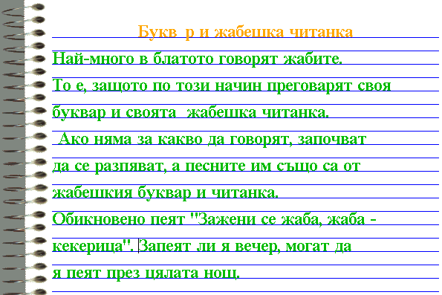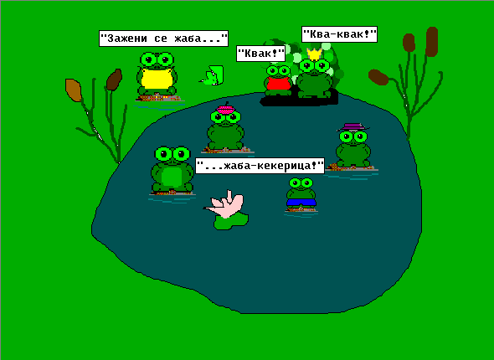
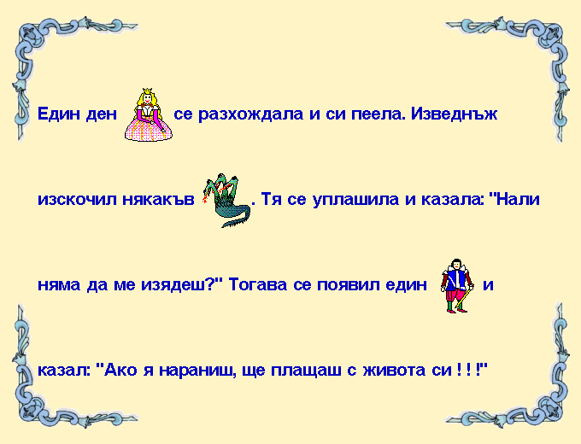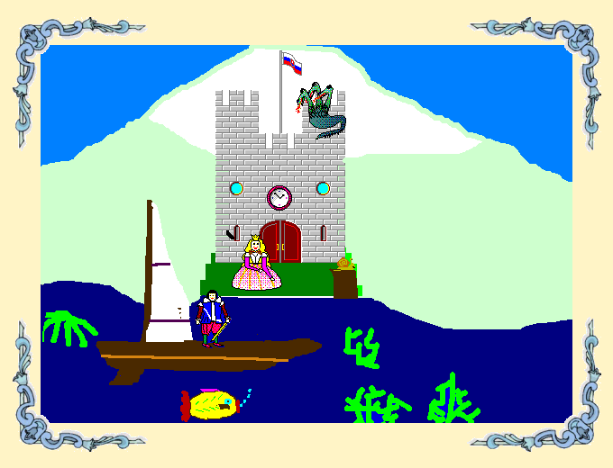
A comic
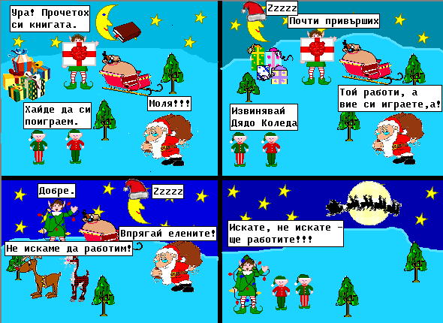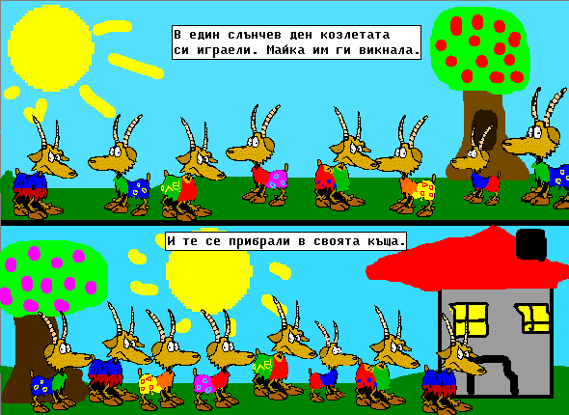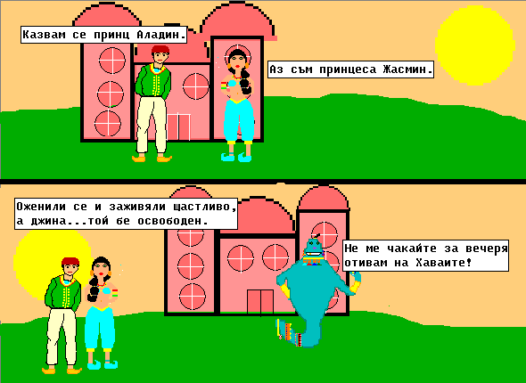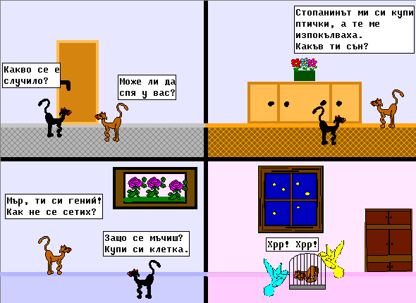

A slide show or a film.
The important thing in any such case is that the product is created by the child personally. She or he has to apply, in the process of creation, the knowledge and skills acquired; to improve them; and even acquire new ones.
When acquired knowledge or skill can immediately be used in practice towards the achievement of a particular goal, one which is personally important, this generates interest. From this comes motivation to acquire more and more knowledge and skills; and put conscious, voluntary effort to this effect. This turns the child from an object of education into an active participant/subject in the process.

LEGO
If LOGO is a high-performance programming environment that has enabled us – the adults, to create a wide range of microworlds dedicated to one or other specific purpose and where children can learn by acting, LEGO is also a high-performance material environment, but one in which the children themselves create their own microworlds. Again it is of the greatest importance in this situation that they learn through action.
Working with LEGO constructional materials the children come to know the surrounding world by recreating it. The elaboration of any model places the child in a situation of very dynamic activity. This is not merely the activity of manipulating elements and building a structure. The situation encourages the child to remember, examine, juxtapose and analyze the object in depth both as a whole and in its details; to seek and find the relations and interactions between parts; to realize functions, purposes and dependencies. The active action is not merely a complement - it is born and needed by the highly intellectual activity, and the great emotional attachment of the child to what they are doing.
LEGO and ICT
In this context I have been using LEGO in my classes as a part of teaching about and with the new technologies. It initiates the children into the world of programming by showing them how to use the computer to control and operate the functioning of external objects.
The fact that these objects are actually the models they have created is almost guarantees the children's personal commitment to the activity. Basic principles are being learned in the course of the practical activity of model operation and control. Complicated explanations are avoided.
Both construction and programming require and develop the following skills:
imagining the whole;
analyzing details;
forecasting consequences;
realizing correlations;
following sequences;
seeking precise expression;
seeking options.

The result of programming is very attractive and devoid of abstraction. It is easy to formulate as a prior expectation and clear to describe step by step, as it concerns behavior that the child knows from the real life. The errors are quite flagrant and the disappointment – quite strong.
The emotional involvement of the child in the model emerging in the course of its creation is transferred to programming which appears in this case as the final stage of the construction event. This is a strong motivation to maximum concentration, to seek options, for error identification and troubleshooting.

Organization of the work
For twenty years I have taught LEGO and ICT in primary school. I began this work in an experimental school and continued it in a private school. Both schools made it possible for what I wanted to do to be a full part of the school curriculum. So, in my present school, all pupils from 1st for 4th grade take two class hours of information technology and two class hours of LEGO construction weekly. To conduct the classes the school equipped a computer room with workstation for each pupil and a LEGO room with enough construction material to enable the common and simultaneous work of all the children in a class.
In the ICT classes the children acquire basic knowledge and skills of working with computer systems and information technologies by creating their own products during their work on various projects.
In the LEGO classes they also become familiar with the structural material, the specific properties of each element and its possibilities, by gradually starting to create models. As models become more and more complicated there is a switch from individual to team work.
Like teaching computer skills, LEGO teaching breaks down construction into necessary skills. These are learned, applied, and refined through all four primary classes.
The integration of both subjects starts at the end of the second and the beginning of the third year. The knowledge and skills acquired in the information technology and English language classes, the latter being studied since the first year, find their application in the implementation and programming of their first controllable prototypes. This continues to the end of the fourth year. The prototypes become more complex in structure and function. The greater diversity also poses more challenging programming tasks.
 | ICT | LEGO | TEAMWORK
1st grade | Introducing the computer. Learning to use the mouse. Working with graphics and sound. Using ToolKid, specially designed software. | Get to know the construction material.  Make the first simple models.  Using LEGO bricks. | Individual work to a teacher example. Individual work on their own idea.  First steps to learn to work in a team of two.  Outcome: individual projects
2nd grade | Learning to use the keyboard. Working with graphics, text, animation, sound and combinations of these.  Using ToolKid. | Make a variety of more difficult constructions.  Make more realistic models with many details. Learn to recreate a first simple situation. Introducing controllable models and programming. | Working individually or in twos or threes on  one common theme discussed with and agreed by all children.  Every construction part of the common project.  No isolated models allowed.  Outcome:  class project.

3rd grade | Individual and class projects that combine different types of information.  Using ToolKid, MS Word and Paint and the Internet.  Product:  movies, stories, comics, slide-show. | First robotics projects using sensors.  Programming with procedures.  Modelling more complex situations. | Freedom to choose and change team membership in the context of each new class project.  Learn to cooperate with the work of the younger children on school projects.
4th grade | Use of the Internet, Paint. Word and PowerPoint to make individual and class projects based on the curriculum for other school subjects. | Larger and more complex robotics projects. Programming with super-procedures and conditions. | Coordinate the work of all classes on whole school projects.  Organise a presentation, introducing the work of all children, to the school and parents.

Inserting this course to the regular curriculum and providing the necessary technical support to conduct it has enabled all the children to participate on equal terms. They all participate in a continuous and consistent training evenly spread over the entire four-year span of the primary school. This makes it possible to establish continuity between and relations among the year groups.
Themes and models
In her/his work the teacher is often facing a situation when she/he has to act as mediator between the new educational ideas, technologies, means and materials, and the child – the end user for whom they are intended. The teacher reduces the overall idea to a sequence of specific steps and actions in order to make possible its practical realization. She/he negotiates the interaction between the idea and the child to whom it is intended. In construction this is carried out through the topics on which the children work and the prototypes they are creating.
In my work with controllable prototypes I use the LEGO Data Control Lab. For the primary school age group this system provides me all the necessary devices and tools to work with the children in a wholesome way. The only problem is that the published technical schemes of models are not intended for primary school kids and therefore they are not appropriate for them. The models are too complex as structures, the objects to recreate are vague in terms of "behavior", and insufficiently attractive as ideas since children are very unlikely to meet them in their everyday life.
Therefore in thinking over the prototypes I bear in mind two things: a) the complexity of the structure into which the computer-controlled element is going to be integrated, and b) the complexity of the guidelines to be followed for its implementation.

Thus, I choose models that:
Can be implemented by the children as a construction task with their available skills and materials;
Naturally presume the presence of controllable devices – motors, lamps, sound elements, sensors;
Will be attractive in both appearance and "behavior";
Recreate objects familiar and interesting to the children;
Recreate "behavior" that could be met in real life, and that is simple and clear enough to be described and then programmed.

The task is never reduced to the mere elaboration of an isolated controllable model. It should be an element of a situation reproducing as closely and realistically as possible the object's natural environment and its functioning within it.
The design of situations is more motivating, more challenging and more creative than the mere creation of an isolated prototype. It is richer in correlations, interactions and dependencies which should be sought, identified and recreated deliberately; which implies better cognition. The situation around the controllable model and its interlacing with other surrounding objects as it is in real life makes its "behavior" more authentic. The behavior is more understandable as it is somehow dependent on its ambiance and interacts with it. This helps the children to see more clearly the algorithm of functioning of the model and comprehend its purpose. In turn, this gives more sense to programming and reduces the degree of its abstraction. Moreover the modeling of situations is conducive to the organization of team-work. The objects are numerous but they are all elements of a large comprehensive project. Every child participates actively in creation, making his/her individual contribution as a part of the whole. Another advantage is that there could be more than one controllable object which makes programming richer, more sophisticated and more open to variation.
Projects
Street lighting
I use street lighting first, to teach the elements of the operation and control system including: computer, interface block, model with integrated control device, and cables for the connections in between. The purpose and functions of each of these elements is explained.
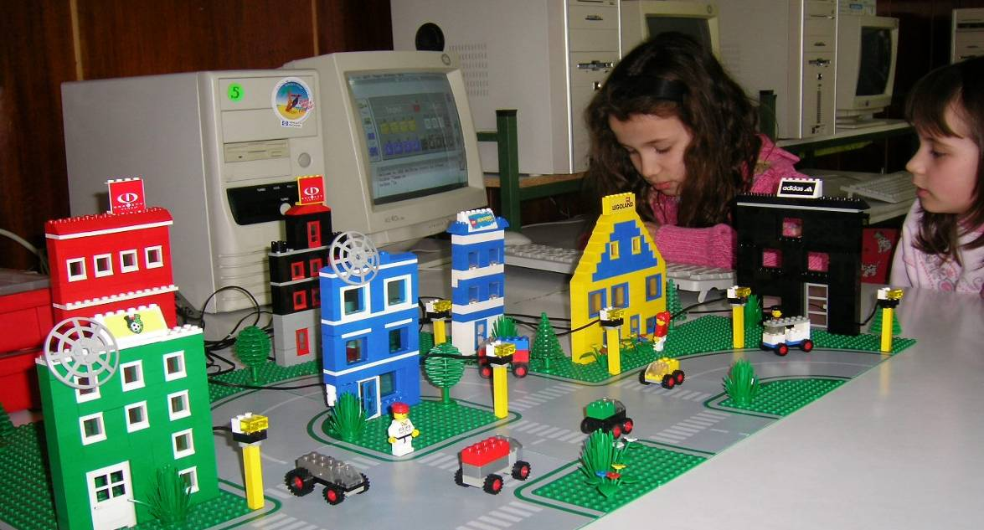
The modes of cable connection to the different devices and the test port functions are shown. The operating algorithm, main interface of the operating program, introducing the control commands and their execution in direct mode of operation are demonstrated.
Children's own experience – they have all seen the street lights and know that the lamps are switched on every evening and switched off in the morning and they are aware that this is being operated centrally and not by employees walking about in the streets to make this manually. The project includes the construction of a city with streets and street lamps placed along them.
Controllable devices – lamps.
Commands – talk to, on, off, wait, repeat.
The work on this project is continued into the third year, by including use of light sensor in order to associate the lamp operation to a particular condition. This entails the natural necessity to introduce the waituntil command to set the conditions. The work is no longer in direct but procedure mode.
Traffic light
The project incorporates the elaboration of a small village with one main street with a pedestrian crossing with a traffic light on it. One side of the street is bordered by the houses. On the other side are – the shop, the post office, the restaurant and the school. The traffic light is necessary to help people reach the place they live, work and amuse themselves without risk of accidents.
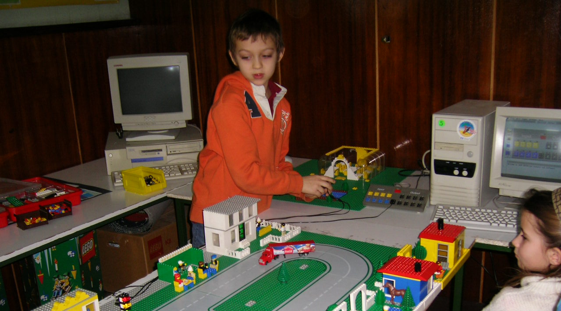
The connection of the devices, the operating program opening and the service check are being performed without help from the teacher.
Children's own experience – they know the traffic rules, they have observed how the traffic lights work day and night, they can describe the algorithm of operation and associate it to their own behavior as pedestrians. Analysis of the traffic light operation in night mode – blinking orange light.
Controllable devices – lamps.
Commands – Refreshing the commands of the previous session, their meaning and the consequences of their execution. Work in direct mode where the children try their own various hypotheses about the sequence of commands to put the traffic light in proper operation. The traffic light is in continuous daytime mode of operation. Introduction of the onfor and forever command.
A similar project is being worked on in the third year, this time in the city with traffic light for pedestrians and cars at a crossroad. It includes the use of sound element as a sound signal to the traffic light, intended for people with visual impairments. This makes it possible to associate the operation of a device, i.e. a lamp with another device, i.e. a sound element. In this situation it is necessary to think about not only the programming solution but also the scheme of connecting the devices to the interface block. The project can be further developed by including a light sensor and linking the traffic light functioning to a condition, according to which it is switched from daytime to night mode and vice versa, as was done with the street lamps.
The work is organized in procedure mode. The idea of a main procedure with sub-procedures is introduced.
Windmills
Introducing a new controllable device – the motor.
Functions – to drive the windmill propellers.
Learning how the motor is incorporated within the windmill prototype structure. The project includes the construction of their own windmill by every child – before that a conversation is held on its purpose, appearance, functioning.
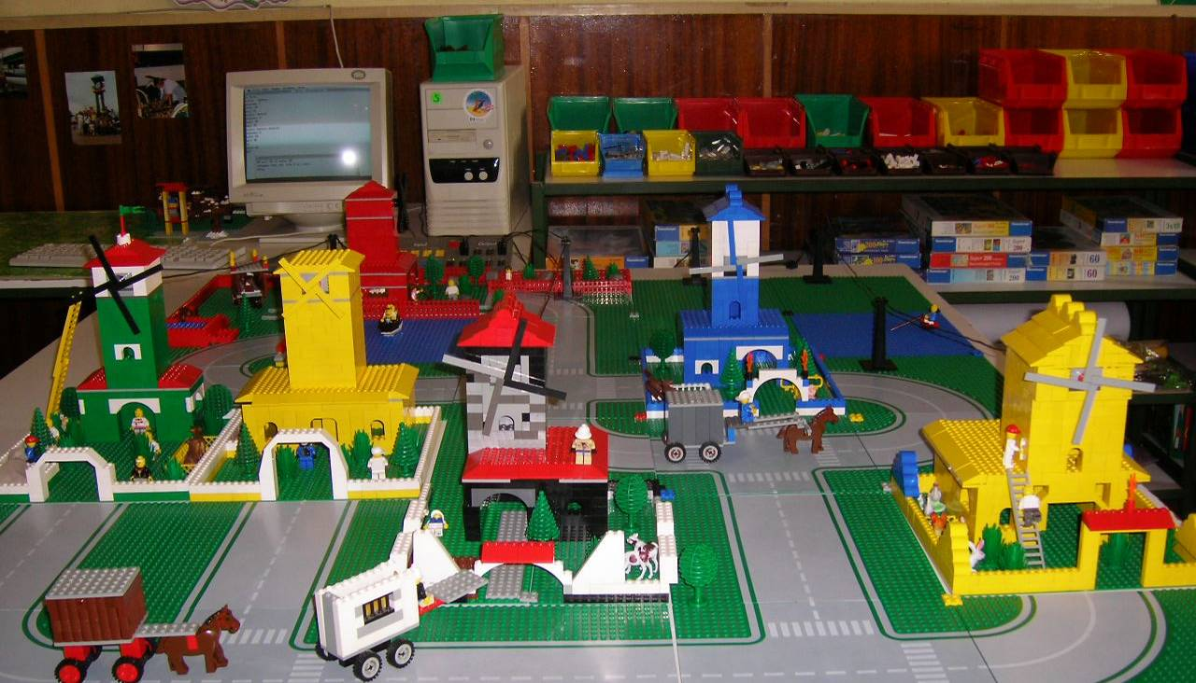
The children's own experience – they have seen working windmills and know what they are used for. A situation including the participation of people and animals should be recreated around each windmill model.
Introducing the rd command for the direction of rotation of the axis driven by the motor. The setpower command is introduced too.
The work goes into procedure mode. The "behavioral" idea of the models is suggested by the children. A condition is set for the windmills to work on different algorithm. Every child first creates a procedure to operate its own windmill and thereafter they create one main procedure to bind together the functioning of all other mills in a common sequence. All the patterns form an integral model through connecting pathways and landscape designed around them. This project is worked on in the third year.
Discotheque
A group project the purpose of which is to make a model of discotheque with air conditioning and programmed lighting.
The children's own experience – they know how a discotheque looks like, what do people do there, they have observed the light effects and are aware of the presence of air conditioning system and its purpose.
Introducing a new device – temperature sensor and associating it to the operation of the fans. The lights programming here requires maximum attractiveness and diversity. The forever command is introduced/used.
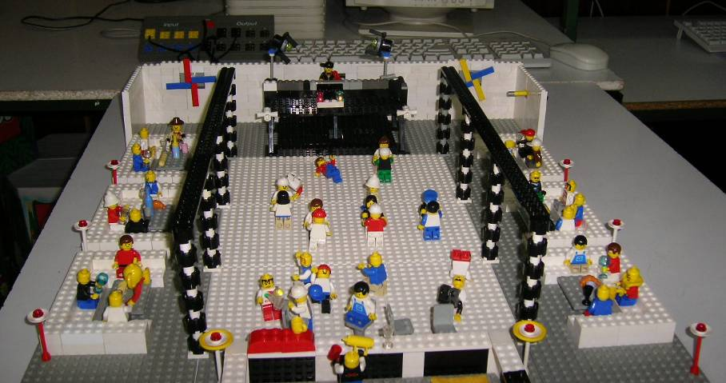
Operation – working in procedure mode. Separate small procedures are created for the various types of light effects operated by one main procedure. The main procedure also includes the fan control procedure.
Working with the sensors makes the projects more attractive and the programming more complex. The children learn:
- why we need sensors in real life
- what they do
- how we can use them in our models
- programming – necessity for high-level procedures and decision-making
Police Action
This project is being worked on in the fourth school grade. It is intended to recreate a story with a plot. The story is based on how to keep your house safe from burglars when you are not at home.
The situational model includes a street with several houses and a police station. One of the houses is equipped with alarm system. A light sensor is installed in the anteroom against the front door. There are signal lamps installed in the police building. A prototype of police car is made, which embodies an engine and siren. Another car prototype with an engine is made for the thieves. The task is to make a program so that the thieves' car starts first and stops in front of the house front door. While the front door is open, the light sensor detects increased lighting. This causes a blinking signal light to go on in the police station. Five seconds after it starts blinking the police car should set off with siren sounding and stop right in front of the house.
The children write the story of a burglary in a program. Procedure mode is used with main procedure and sub-procedures. They write a procedure car for the car of the “bad people” who come to rob the house. They write a procedure alarm that connects the working of the sensor with the working of the alarm. They write a procedure policecar that controls the movement of the police car so that it goes exactly to the house. The superprocedure police controls all of the action.
The class is divided into teams of 2-3 children: The team constructing the house is in charge of programming the sensor control; and the team designing the police service is in charge of the signal lamp programming etc.
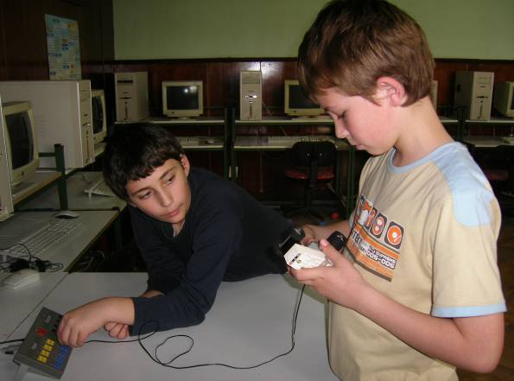 | 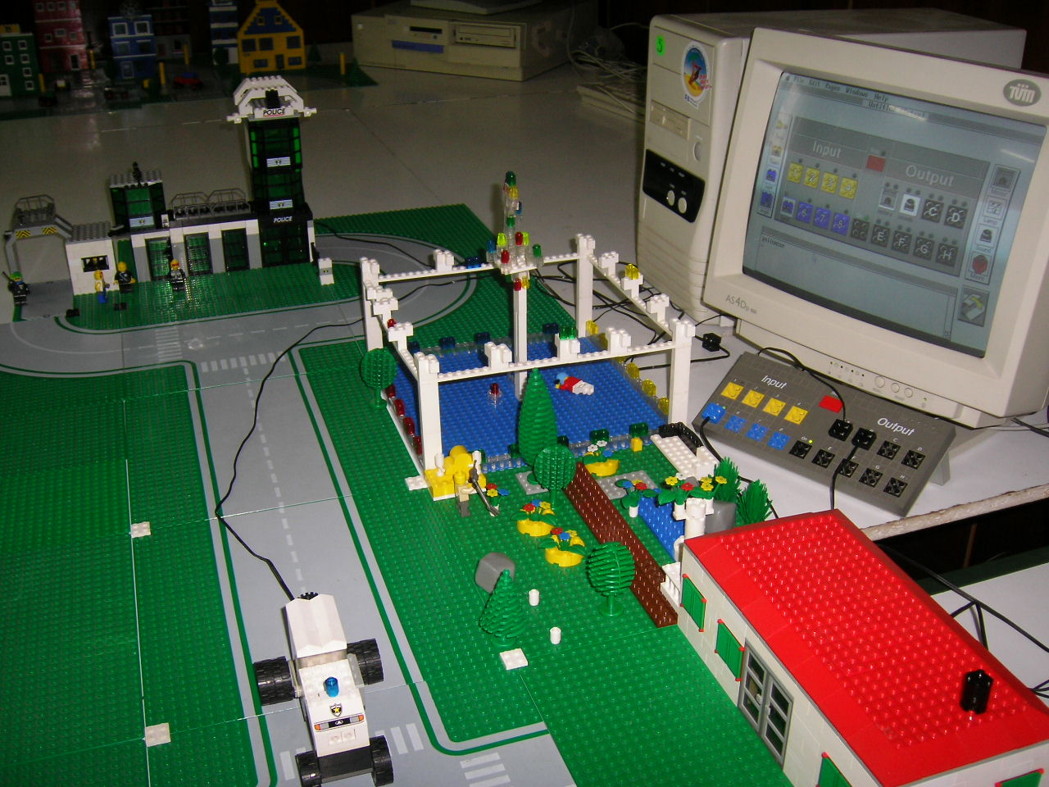
Christmas Town and Amusement Park
These are collective projects with the participation of all the children from 1st to 4th grade.
The Christmas Town is a project in which all children from the primary school participate. The youngest make simple houses, streets and the skating rink. The older students make more difficult models like the church, hotel and Christmas tree. They also program the lights in the town and on the tree. We make it every year before the Christmas holidays.
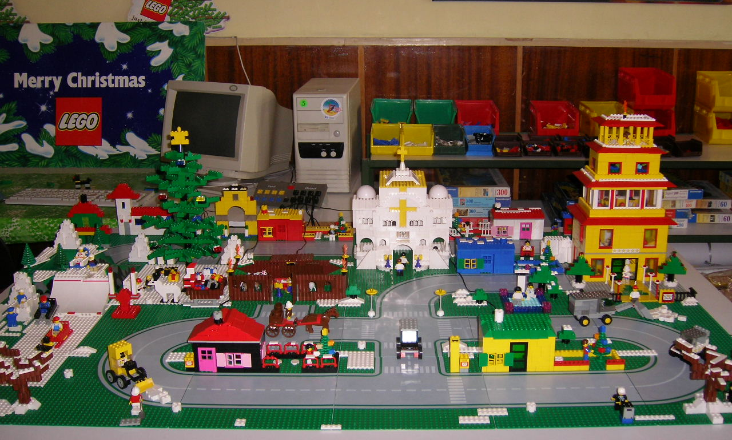
The Amusement Park is a project for the end of the school year. The model is large and every class takes part in it by implementing some part of the common subject. The youngest children make the simple attractions, the places for food and the park/setting. The older students make the models of the different types of ride and program them to work.
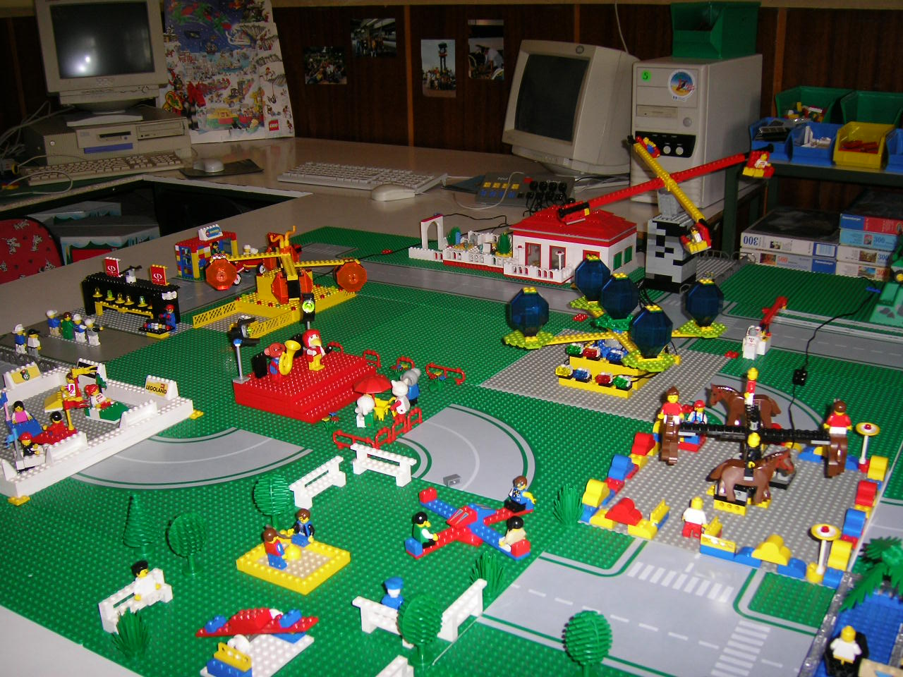
In summary
Organizing ICT education as work on personal projects, which leads to the creation of an end product with a personal meaning to the child, provides a different context in applying knowledge and skills and guarantees the child’s personal activity during that education.
ICT and LEGO is an inviting and challenging environment that enables children :
- to act
- to think
- to have ideas
- to create
- to be emotionally engaged
- to come to know the surrounding world
The teamwork during these classes hours and the group projects of the class in the ICT and LEGO lessons are very important for the children themselves and the school life in general. Many ideas are generated in the teamwork, the communication is dynamic, the disputes which arise cultivate the ability to find arguments, to compromise. This environment is beneficial to multifaceted and diversified reasoning, to the formation of ability to take independent decisions and bear the consequences of it. The traditional teaching quite rarely provides natural opportunities and necessity to work in a team.
Regardless of the fact that I have discussed these school sessions mainly within the context of the ICT classes I believe that they are influencing in a specific way the entire development of the children, the school environment and the pupils' attitude towards studying and education.
References
Ilieva, V. and Ivanov, I. (1999): Informatics and Information Technologies in Primary School – based LOGO Environment. In Proceedings of EuroLogo 1999. Edited by R. Nikolov, E. Sendova, I. Nikolova, I. Derzhanski. Sofia, August. pp. 227 − 234.
Ilieva, V. and Ivanov, I. (2001): My First Computer Software. In Proceedings of EuroLogo 2001. Edited by G. Futschek. Linz, August. pp. 277 − 285.
Ivanov, I. and Ilieva, V. (2005): ToolKID – Logo language based software package for children. In Proceedings of EuroLogo 2005. Edited by G. Gredorczyk, A. Walat, W. Kranas, M. Borowiecki. Warsaw, August. pp. 390 − 397.
Ilieva, V and Ivailov I. (2003 – 2006): Компютърът в началното училище, Vols 1-5, Sofia, Regalia 6
Ilieva, V. and Ivailov, I. (2004 – 2007): Информационни технологии, 1-4 клас, Vols. 1-4, Sofia, New Star

An Elica Logo Perspective on Educational Serious Games
Pavel Boytchev
Department of Information Technologies
Faculty of Mathematics and Informatics
Sofia University, Bulgaria
boytchev@fmi.uni-sofia.bg

Glimpse of the past
Personal learning is always marked by milestones. Although its pace is individual for every person and although different countries and cultures have different educational systems, there is phasing of learning which is almost consistent for all – see Figure 1.
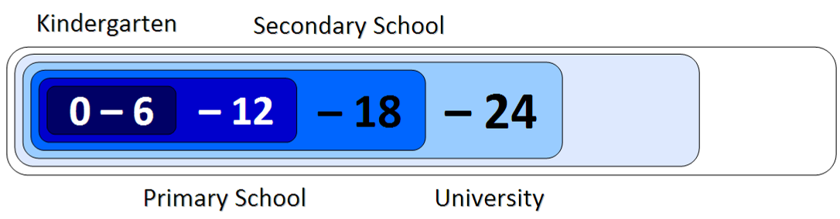
Figure 1. Learning phases
The learning in the first six years are spent in the kindergarten (either public, private or at home). The second phase is the primary school, followed by a period for secondary school and the last 6-year period is for the higher education. The terms “kindergarten”, “primary school”, “secondary school” and “university” are just indicative. They are not meant to fix the actual place of learning, but show the style of learning.
A similar phasing can be observed in the design and development of ELICA – Educational Logo Interface for Creative Activities, which milestones are coherent to HungaroLogo conference – see Figure 2. This coincidence might be purely by accident, but yet we need to wait until 2017 to get a more reliable conclusion.
Elica was initiated in 1999 at the U.S.A.-Bulgaria forum “Mathematics and Computer Science Education”. It received a grant award by the Best Practices in Education Company.
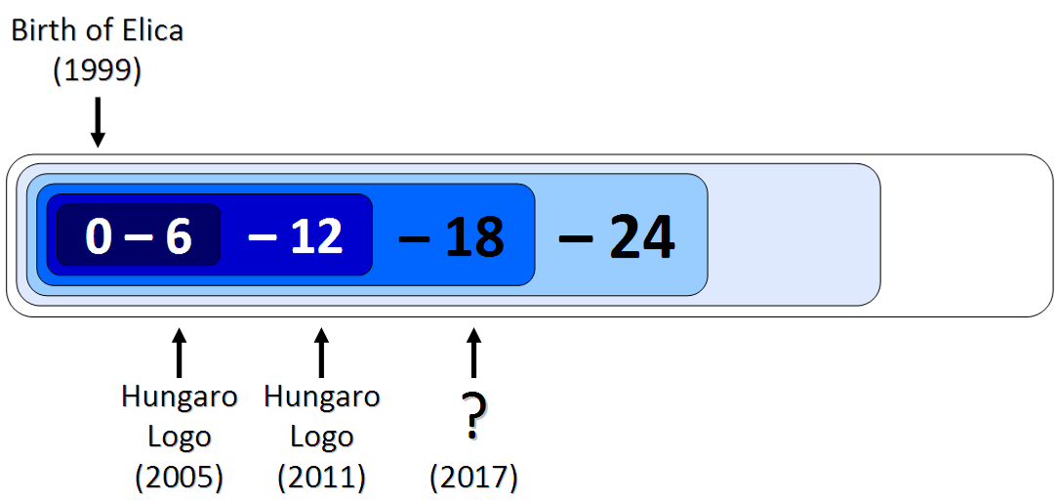
Figure 2. Elica and HungaroLogo conference
Six year later the author was invited by Károly Farkas to HungaroLogo 2005 where he presented two papers: “Elica – It’s More than Just Another Logo” and “Elica – Natural Object-oriented Programming”. These two papers discussed some core features of Elica and they marked the end of the kindergarten period of Elica development. During this initial period Elica was used for educational applications, but the main focus was on the development of Elica itself.
The development of Elica continued for the next six years and more advanced features were implemented. At the same time, Elica was used for the production of sophisticated educational software which gradually comprised features typical for games. The spectrum of activities available through Elica-based applications was beyond any initial expectations and hopes.
The milestone for the second period is in this year, 2011, when the author was again invited by Károly Farkas for HungaroLogo 2011.
Educational Serious Games
Serious game is a collective term used to describe a set of various applications and their supporting techniques. Serious games are game in respect to the fact that they are presented as a game, usually in a virtual environment and providing some level of freedom to the user to decide how to play. At the same time serious games are not focused on the entertainment as long as the main goal is to make the user learn something, gain skills or experiment with various situations. Serious games are bound to processes and events that are sometimes fictional, but believable, other times they are very close to reality.
There are many classes of serious games, depending on the topic of the game. However, the two main classes are the business serious games and the educational serious games.
Business serious games represent virtual business environment populated with playing and non-playing characters, artefacts and other entities [1]. They are used to gain and develop business-related skills and experience.
The author took part in the design of two business serious games. Project PRIME (Providing Real Integration in Multi-disciplinary Environment) was a European Framework Program 6 project. Its goal was to build a virtual environment for gaining practical experience in strategic manufacturing [2].
The other project is TARGET (Transformative, Adaptive, Responsive and Engaging Environment). This is a European Framework Program 7 project and is still ongoing. The goals are to research, analyse and develop environment for rapid competence development of individuals.
Educational serious games represent virtual educational environment where players can develop skills in general areas of education. Two of the international project where Elica was used are the European Socrates project DALEST (Developing Active Learning Environment for Stereometry), which comprises a set of educational, interactive and dynamic 3D game-like mathematical applications; and the European Lifelong Learning project InnoMathEd (Innovation in Mathematics Education on European Level) focused on the development of pupils’ key competences and their ability to use ICT for learning processes in mathematics.
VirtualMechanics is an ongoing project, partially supported by the Sofia University fund for scientific research. It is a microworld for experiencing engineering of virtual mechanical devices.
ELICA
ELICA is a platform for development of educational software which uses virtual 3D microworlds. It is one of the 248 Logos as described in the Logo Tree Project.
The programming language of Elica is Elica Logo – a modern dialect of Logo supporting Natural Object-oriented programming. The core of the language is minimalistic – there are only 10 reserved words. The main advantages of Elica are that it supports 3D animation in real time, it has an integrated development environment and it is free.
All research described in this paper is done in Elica or with Elica. This includes the participation of DALEST and InnoMathEd projects. Additionally, Elica is used to develop other educational materials, to build microworlds for secondary school [3] and to support several university level courses [4].
The early use of Elica was about building individual applications that are closer to conventional educational software rather than to educational games. These applications were (and possibly still are) used by Stevens Institute of Technology (NJ, U.S.A.), New York University (NY, U.S.A.) and Saturday Academy (OR, U.S.A.)
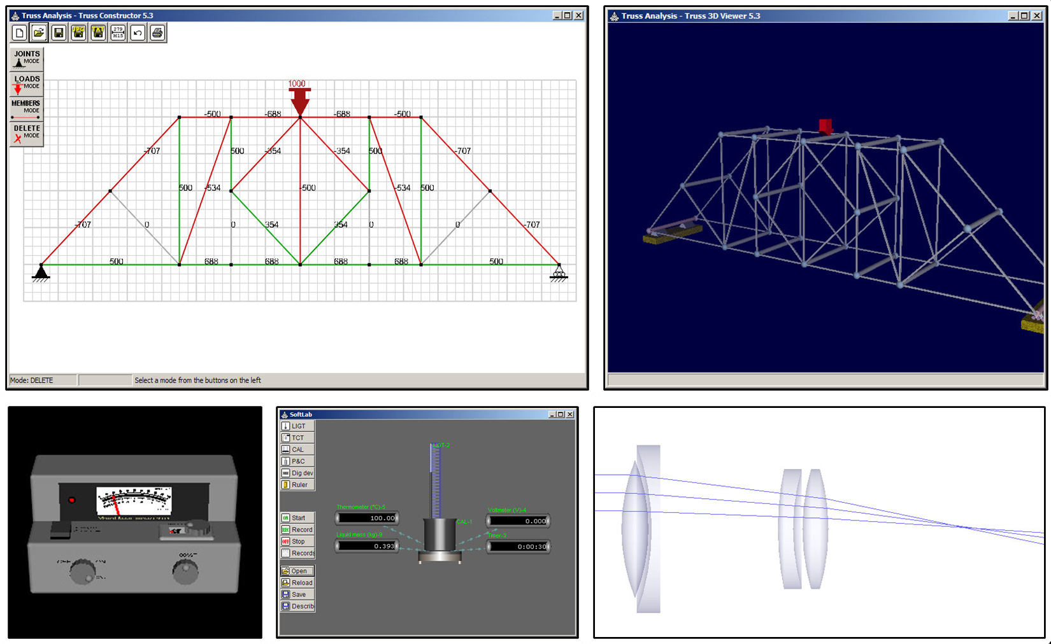
Figure 3. The Truss Analysis and other program
Figure 3 (top row) shows snapshots from the Truss Analysis program which is used to design truss structures. Other educational applications are shown in the second row: a virtual model of Spectronic 20; SoftLab - a virtual laboratory for thermodynamics [5]; and a virtual environment for designing compound optical systems.
Nowadays Elica is used to build various models covering a wide area of topics. Figure 4 shows snapshots of a few models: a topological representation of a hole through a hole in a hole; a model of the Solar system; a military helicopter; romantic pigs; seismic membranes of 5000 earthquakes; animation of equirectangular projection; a hypercube and an interactive application-proof of the Pythagorean theorem. A complete collection of on-line accessible animations of the models can be found in ElicaTeam’s YouTube channel.
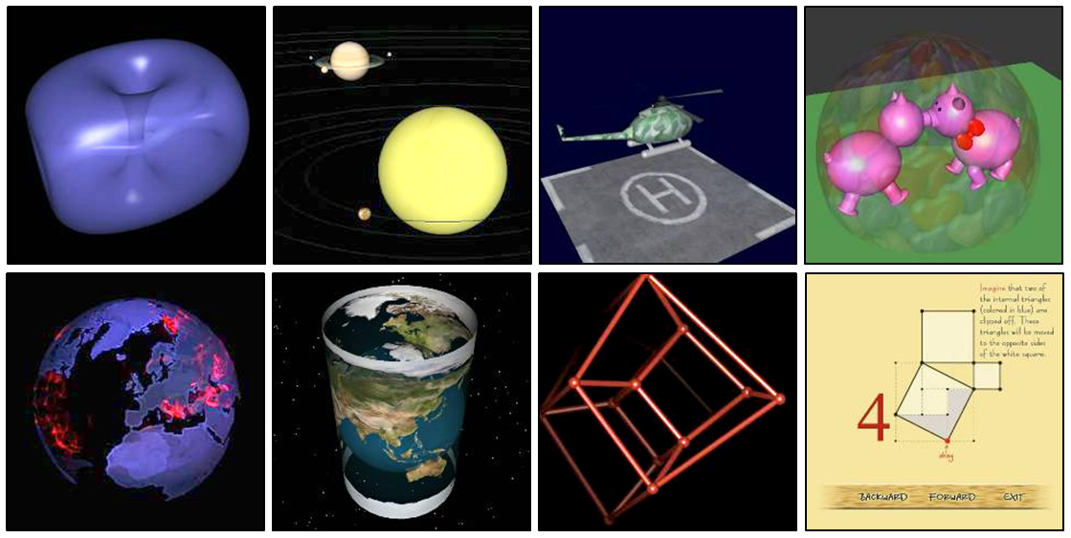
Figure 4. Snapshots of various models built in Elica
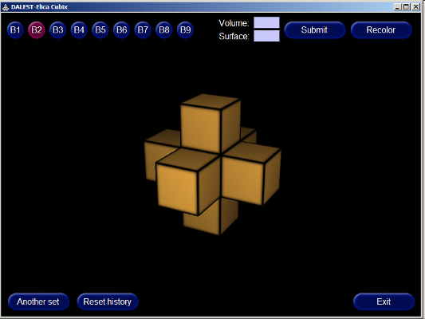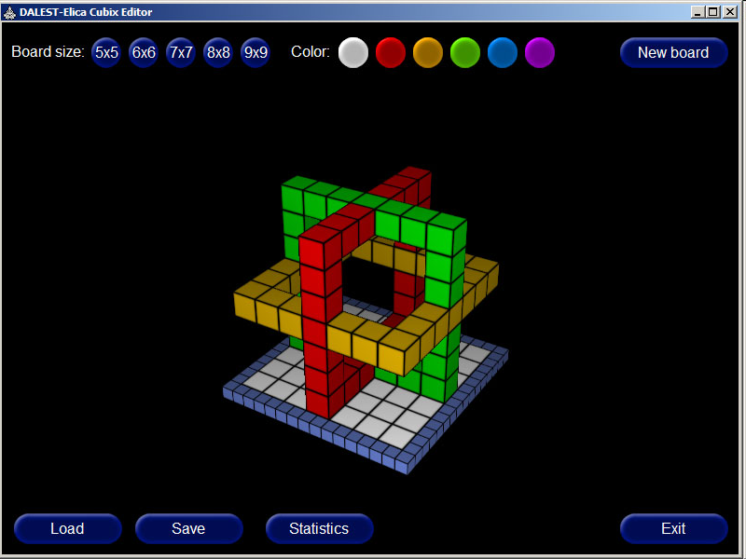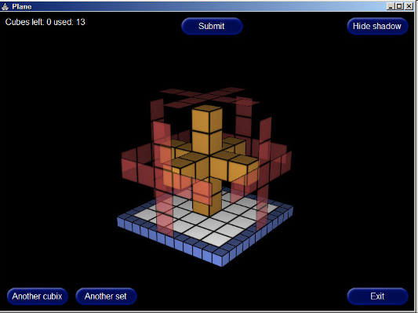
Figure 5. Cubix applications
DALEST project
Two distinct software development streams were realized within the DALEST project. One of them was the design and implementation of a monolith .Net application and the other is a set of 10 Elica-based applications [6]. The main challenges in the design of the Elica-based applications were:
- To find unique problems. These are problems that have not been overused by textbooks and web sites. Without uniqueness, the applications would just recreate something that already exists.
- To rationalize the use of computers. Problems that can be expressed in hard copy (i.e. static images) can be converted into educational software, but this is just a change of the media. To justify the use of computers the problems must be something that cannot be presented adequately without computers.
- To provide attractive visualization. A key component of games is that they are visually attractive. A schematic visualization of mathematical concepts is not that appealing, so the Elica application must utilize techniques from the gaming sector, namely virtual reality, 3D graphics and interactive real time control.
The application that were built for DALEST could be categorized in three groups; Cubix, Rotational solids and Mathematical surgery. The Cubix applications present mathematical problems and puzzles using structures of unit-size cubes. They also allow the construction of such structures. Figure 5 shows snapshot of these applications. The Cubix application (left snapshot) is used to solve mathematical problems of finding the volume and surface area of structures. The Cubix Editor (middle) allows the player to build his/her own structures and solve word problems [7]. The Cubix Shadow (right) is a virtual puzzle aimed at recovering a structure knowing only the shapes of its shadows.
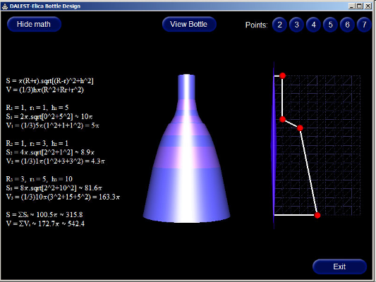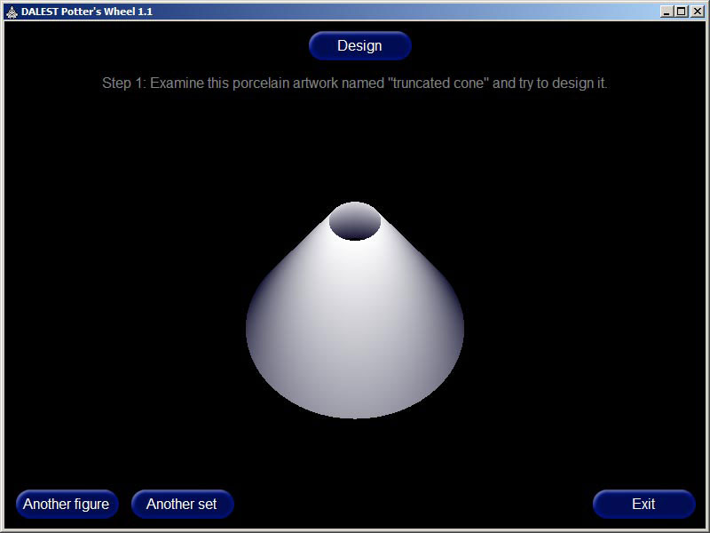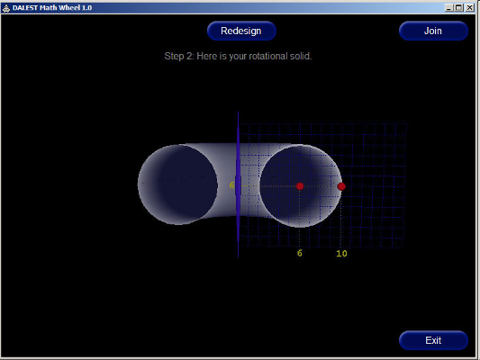
Figure 6. Rotational solids
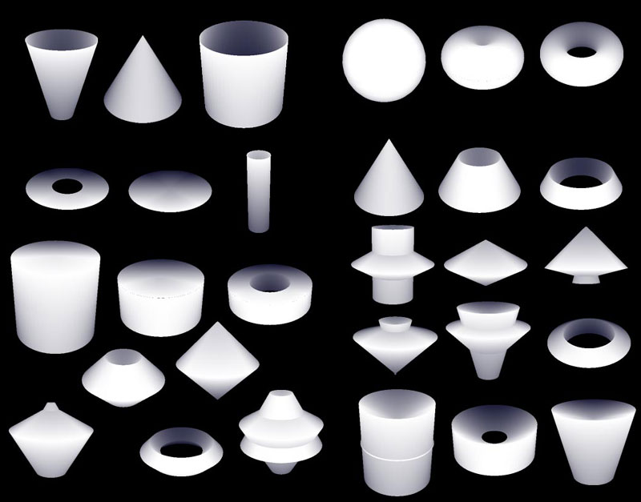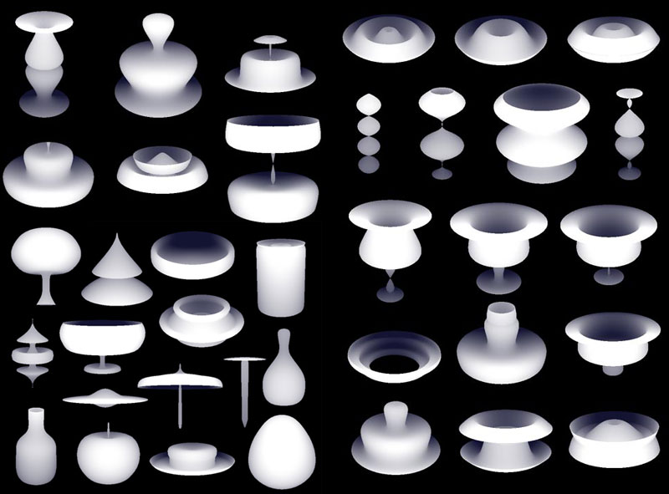
Figure 7. Some of the shapes in the Potter's Wheel
The main features of the three Cubix applications are that they provide simple representations of complex tasks, they utilize the power of recreational mathematics and they provide a game-like interface.
Rotational solids use silhouettes revolved around an axis and thus defining a solid – see Figure 6. There are various tasks that can be applied to such solids. The Bottle Design (left) application allows the player to design the shape of a bottle and calculate its volume with sufficient approximation. A similar application is the Math Wheel (right). Instead of a bottle, the silhouette is defined by a simple geometric shape. Finally, the Potter’s Wheel (middle) explores the diversity of solids that can be obtained by rotating a simple silhouette – see Figure 7. The Rotational solids bridge mathematical problems with the interactive 3D graphics. Some of the problems are related to real-life problems and at the same time they support the creation of a broad diversity of artefacts.
The third category of applications in the DALEST project is related to various aspects of mathematical surgery – see Figure 8. The Origami Nets (left) is a virtual interactive constructor of solids. Players use different types of 2D panels, attach them one to another to build a solid. The Slider application (middle) shows the intersection of an invisible solid. By inspecting this intersection (the user can move the intersecting plane) the player has to guess the shape of the invisible object. The Scissors (right) invites the player to rip the edges of a cube so when it is unfolded to get a specific figure.
The main benefits of the mathematical surgery are the novel set of tools for interactive construction and the possibility to explore problems from new points of view, which are hard to implements effectively through a static media.
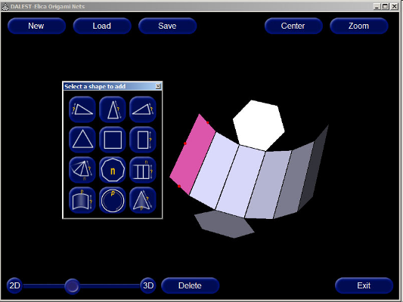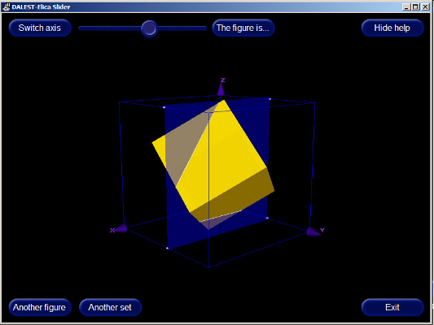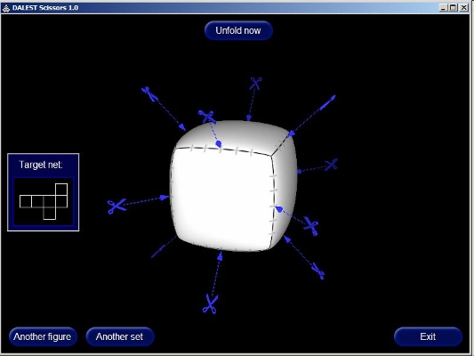
Figure 8. Mathematical surgery
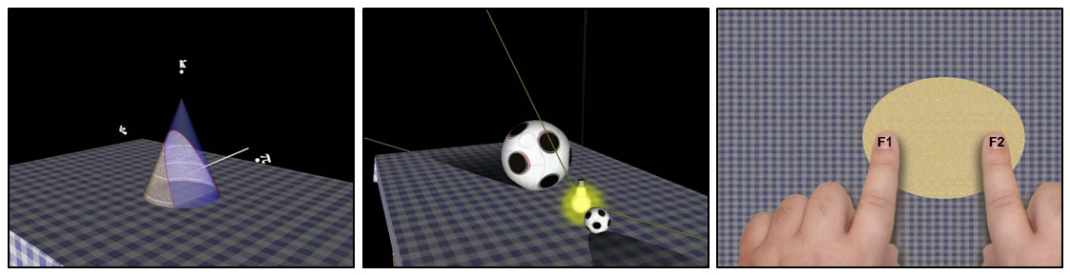
Figure 9. Some of the InnoMathEd applications
InnoMathEd Project
The use of Elica in InnoMathEd was as a platform for development of educational game-like software demonstrating conic sections. The applications span from the traditional representation to an imaginary pizza making.
Figure 9 (left) is a snapshot of an interactive application representing the traditional (also canonical) view of conic sections. A handle attached to the intersecting plane can be moved by the user, thus producing all four types of conic sections. If the handle points to κ the intersection is a circle, if it points to π it is a parabola. And interesting phenomenon is easily represented, namely, there is only one parabola (i.e. all various parabolas are fragments of the same curve); while there are many distinct ellipses (between κ and π) and hyperbolas (beyond π).
The middle illustration in Figure 9 shows a generation of conic section by using spheres and a source of light. The shadow of a sphere is a conic section and the table is the intersecting plane. The position of the shadow in respect to the sphere has an important mathematical meaning – it touches the table at the focal point of the conic curve. Additionally, the balls as Dandelin spheres as described in [8]. The interactivity of the application allows the player to move the light source, to rotate the whole scene and to zoom it in or out.
The right illustration in Figure 9 is another interactive application. Initially two fingers touch the centre of a circular pizza. If one of the hands is moved the pizza is extended to an ellipse. When the hand goes to infinity the pizza becomes parabolic and when it goes beyond infinity (i.e. it wraps from the other side of the table) the pizza is hyperbolic.
Virtual Mechanics Project
This project started as an internal project, but has occasionally received support by the faculty. The core of the project is a set of more than 60 virtual devices that represent mathematical concepts. All the devices and short animations of their work are programmed in Elica.
The main goals of the project is to help users model and engineer various mechanisms; to represent mathematical knowledge in an interesting way; and to practice programming in virtual 3D microworld.
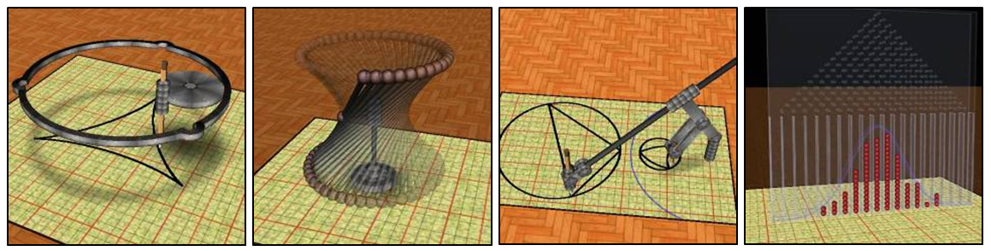
Figure 10. A few of the virtual devices
The diversity of representable mathematical knowledge is very high. Figure 10 shows just a few of them (left to right): a device drawing a deltoid curve; a rotational model of hyperboloid surface; a 3D mechanism for geometrical inversion; and a simulation leading to the normal distribution.
Some of the mathematical concepts are represented by different machines. For example, there are many ways to generate an ellipse. Seven of them have been used to make a mathematical movie called “Ellipses…” – see Figure 11. The animation in the movie is programmed, so it could be used both as an artistic artefact and as a learning object.
The future plan related to the movie is to use it as a book of problems. Every model, used in the movie, is a source of several mathematical problems. Additionally, the source code can be used in Computer Science classes demonstrating OOP, Computer Graphics, 3D modelling and animation techniques.
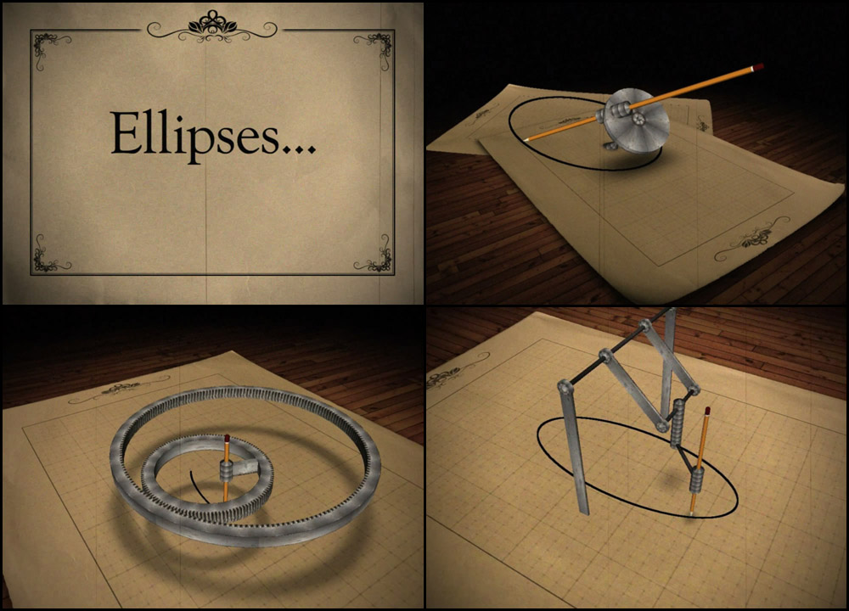
Figure 11. The mathematical movie "Ellipses..."
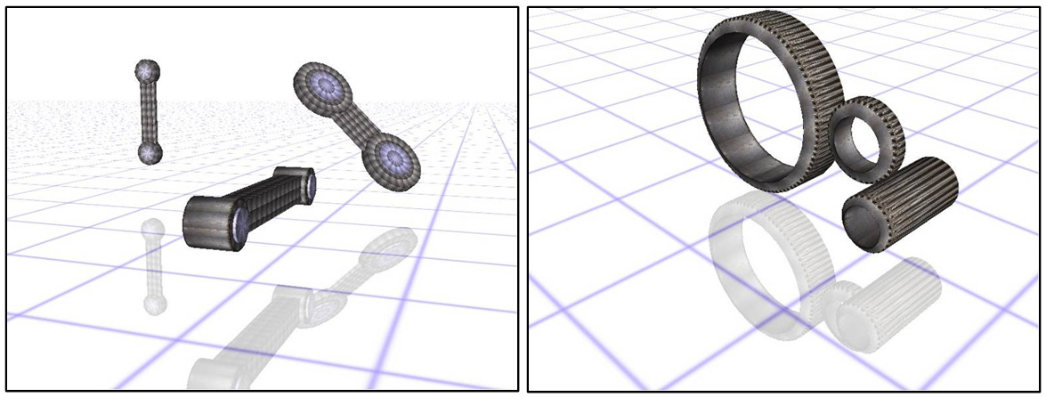
Figure 12. Virtual components
People who watched the movie find it interesting and informative. Here are two opinions: “It's amazing how simple those mechanisms are, yet what complex motion they produce” and “Reminds me of my days before computers learning technical illustration. We were taught how to trammel an ellipse by hand. Forgotten all about it until I watched your movie”.
The microworld of virtual mechanics is now being redesigned in order to provide higher interactivity, design flexibility and more attractive visualization. The new microworld is expected to be both student-friendly and teacher-friendly. It defines a set of virtual mechanical components, as shown in Figure 12, which players can customize in terms of sizes, locations and orientations.
These components could be joined and controlled programmatically as elements of a virtual 3D mechanism. Figure 13 shows a model of the Theo Jansen’s walking mechanism.
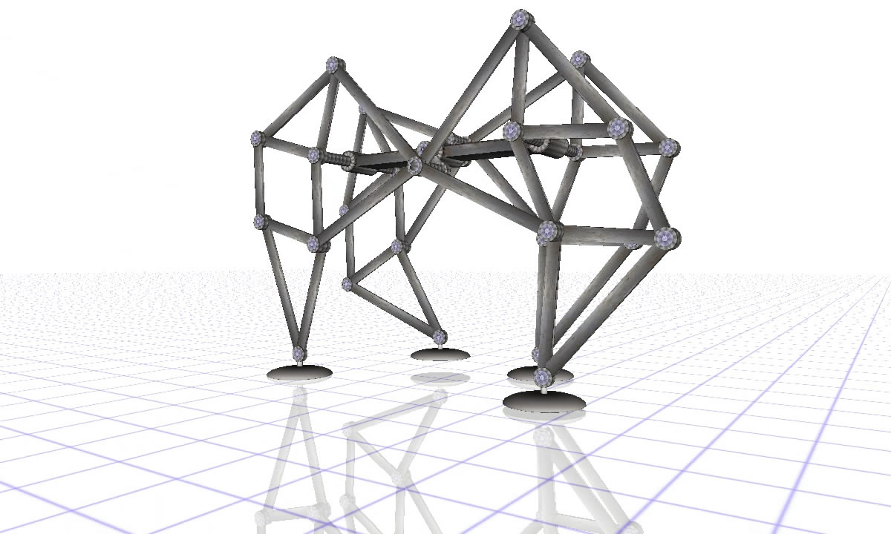
Figure 13. A model of the Theo Jansen's walking mechanism
A Perspective on Educational Serious Games
Although many of the application built with Elica does not possess all elements, required for games (like user profiles, scores and ranking, social functions, etc.) they provide something more valuable in terms of education. They reveal microworlds of different complexities. Some of them (like the DALEST’s Cubix applications) are just small virtual worlds with predefined inhabitants and degree of freedom. Others, like the microworld for virtual mechanics provide a complete programming flexibility. Players can express their ideas as algorithms or program codes. In this context, playing is focused more on creating, inventing and exploring, rather than on entertainment.
Some of the software is already used with students and the results are reported in series of papers [6, 7, 9, 10]. Others, like the Virtual Mechanics project, are still under development and classroom experiments are yet to be conducted.
References
[1] Duin, H., Oliveira, M., Saffarpour, A., (2007), A Simulation Model for Virtual Manufacturing Environments for Serious Games, In Proceedings of 13th International Conference on Concurrent Enterprising, (Eds) K. S. Pawar, K.-D. Thoben, & M. Pallot, Sophia-Antipolis, France, pp. 253-260.
[2] Boytchev, P., Bontchev. B., Nikolov, R., Olivera, M., Koytchev, I. (2006) Designing a Toolset for the PRIME Virtual Business Environment, In Proceedings of the 10th International Workshop of the IFIP WG 5.7 Special Interest Group on Experimental Interactive learning in Industrial Management, (Eds.) B. Hussein, R. Smeds, J. Riis, Trondheim, Norway, pp 41-49.
[3] Stefnova, E., Boytchev, P., Kovatcheva, E., Nikolova, N., Sendova, E., (2007) Information Technologies “You and IT” - 7 grade. Sofia, Anubis (in Bulgarian)
[4] Boytchev, P. (2007), Design and Implementation of a Logo-based Computer Graphics Course, Informatics in Education, Volume 6, No. 2, 2007, Vilnius: Institute of Mathematics and Informatics, pp 269-282.
[5] Rothberg, G., Boytchev, P., (2007), SoftLab Virtual Laboratory Environment. Thermo-dynamics Examples, In Proceedings of Annual Conference of American Society for Engineering Education, ASEE’2007
[6] Boytchev, P., Chehlarova, T., Sendova, E. (2007), Enhancing Spatial Imagination of Young Students by Activities in 3D ELICA Applications, In Proceedings of the 36th Spring Conf. of the Union of Bulgarian Mathematicians, (Eds.) P. Boyvalenkov, P. Rusev, Varna, Bulgaria, pp 109-119
[7] Sendova, E., Chehlarova, T., Boytchev, P. (2007), Words are Silver, Mouse-Clicks are Gold?, Informatics in Education, Volume 6, No. 2, 2007, Vilnius, Lithuania, pp 411-428
[8] Weisstein, E. (2010). Dandelin Spheres. From MathWorld – A Wolfram Web Resource. Retrieved 13 June 2010 from http://mathworld.wolfram.com/DandelinSpheres.html
[9] Pittalis, M., Mousoulides, N. and Antreou, (2009), A Construction of Dynamic Visual Images of 3D Geometry Shapes, In Proceedings of the 9th International Conference on Technology and Mathematics Teaching (ICTMT9)
[10] Mousoulides, N. (2010), Student Developments in Modeling Real World Problems Using Conceptual Technological Tools. In Acta Mathematica 13, volume II. Nitrianska Matematicka Konferencia, 13-17 September 2010, pp. 63-72.

A logo-pedagógia játékai
Kőrösné dr. Mikis Márta:

„Azoknak a felnőtteknek az élete a legizgalmasabb és legteljesebb,
akiknek játékai gyermekkorukban színesek, változatosak voltak,
és játékosságukat meg tudták őrizni felnőtt korukra is.”
(Erik H. Erikson)

A játék szerepe a tanulási folyamatban
A gyermek születése pillanatától – mások szerint már a magzati életben is – tanul. Mindezt játékos formában teszi. Ha önfeledten játszó gyermekeket figyelünk, észrevehetjük, hogy a játék során a saját maguk elé állított akadályokat oldják meg, örömmel és önként. A kisgyermekek játékszükséglete napi 7-9 óra, amely számukra rendkívül „komoly” dolog. Pedagógiai és pszichológiai tanulmányainkból ismerjük, hogy a játék a gyermek legfontosabb tevékenysége, fejlődésének „kulcsa”. A játék tanulási folyamatban betöltött szerepe azért döntő, mert eszközt jelent a gyermeket körülvevő világ felfedezésére, megismerésére. A képességfejlesztésben betöltött szerepe, motiváló hatása rendkívül nagy. A kisiskoláskorra a konkrét műveleti játékok jellemzőek, amelyek bármely műveltségkör ismeretanyagának elsajátítását, felidézését, gyakorlását színesítik, miközben különféle, változatos munkaformákra is lehetőséget adnak.

Sokszor hangoztatjuk a gyermekek előtt, hogy a tanulás „komoly dolog”. Akkor miért játszunk az iskolában, a tanulás legfőbb színhelyén? A válasz rögtön adódik: éppen a tanulási folyamat sikere érdekében. Az iskolai foglalkozások során a játék a gyermek számára nemcsak pihenést, felüdülést, szórakozást biztosít, hanem erőt is ad, és feloldja a gátlásokat. A pedagógus számára pedig azért hasznos, mert az oldott, vidám légkörben jó a lehetőséget ad a tanulók személyiségének mélyebb megismerésére, sőt a tanulók jellemének alakítására. A csoportos játékok becsületességre, őszinteségre nevelnek és megtanítják a gyermekeket a győzni akarásra, valamint a veszíteni tudásra is. A társasjátékok, versenyjátékok a kudarc elviselésével is megismertetik a kicsiket, amelyeknek kezdetben fájó élményét szintén meg kell tanulni.

A gyermekkori játék, illetve a játékos, ismeretszerző, tanulási tevékenységek a felnőttkorra is hatással vannak, ahogy azt az idézett neves német fejlődéspszichológus, Erikson is megállapította. A játékban nincs felső korhatár, és ősi leletek, valamint az egyiptomi sírkamrákból előkerült relikviák is azt bizonyítják, hogy őseink is játszottak. Tutankhamun egyik táblajátéka akár a Logo-hoz illó teknőcjátékok ősének is tekinthető!

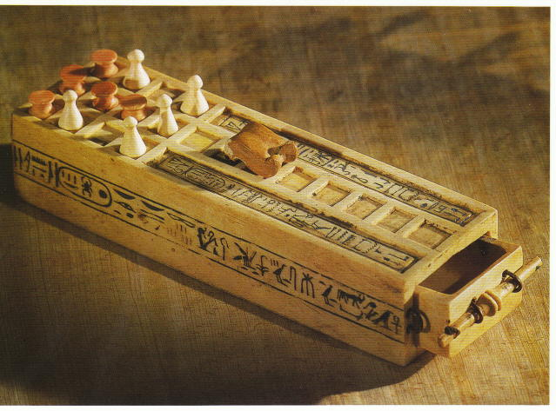

Tutankhamun játéka időszámításunk előtt kb. 1320 évvel

Az információs és kommunikációs kultúra játékos megalapozása
Az információszerzés és -felhasználás folyamatát felnőtt korban már késő megtanulni. Alsó korhatár viszont nincs, hiszen minden egyén – már születése pillanatától kezdve – alkalmas érzékszervein keresztül a jelek, jelzések felfogására, feldolgozására, majd – sok-sok tapasztalat útján – az ismeretek bővítésére, az információszerzésre. Ebben a folyamatban az oktatási intézmények feladata az, hogy az információs kultúra befogadásában, megalapozásában segítsék a gyermekeket.

INFORMATIKA JÁTÉKOSAN? A szókapcsolat hallatán még mindig sokan – tévesen! – korunk korszerű eszköze, a számítógép előtt ülő, annak gombjait nyomogatva játszó, a képernyőre meredő gyermeket képzelnek el. Holott az informatika ebben a korcsoportban egészen más! Olyan tarkabarka, változatos játékok sokaságával közelíthető meg, amelyek mindegyike az információs és kommunikációs kultúra megalapozásában és fejlesztésében segít. Megtanít az információk szerzésére, válogatására, értő felhasználására vagy éppen továbbítására. Beszélő képek, piktogramok megfejtésből kiindulva az irányokat, a helyes sorrendet gyakoroljuk, információt gyűjtünk, sőt: alkotunk. Rajzolunk-színezünk, tervezünk, barkácsolunk, írunk, vagy éppen recept alapján süteményt készítünk. És ha kell, a gyermeki kreativitás érdekében munkára fogjuk a számítógépet is a 3-10 éveseknek szánt didaktikai célú szoftverek segítségével. A játékok formái is változatosak: egyéni, páros, kiscsoportos, és az egész osztályt/csoportot érintő tevékenységek váltják egymást.

Az informatika világával való megbarátkozást – különösen az iskolába lépő gyermekek korcsoportjában – sohasem a számítógépekkel kezdjük. Nagyon sok olyan játékot játszhatunk a teremben, az udvaron, vagy éppen hagyományos módon rajzolhatunk, írhatunk, barkácsolhatunk, amely tevékenységekkel nemcsak az információs kultúrát, hanem a későbbi IKT-eszközhasználatot is megalapozzuk. Játékos tevékenységeink során elsősorban a következő, igen fontos készségek-képességek fejlesztéséről van szó:

- vizuális és auditív felfogó képesség,
- problémafelismerő és megoldó képesség,
- beszéd és kommunikáció,
- figyelem, pontos feladatvégzés,
- alkotó képzelet, kreativitás,
- térbeli tájékozódás, lateralitás, koordinációs képesség, testszintónia,
- manipulációs képesség, mozgáskoordináció
- szellemi aktivitás, önbizalom, önértékelés,
- emlékezet és gondolkodás (algoritmikus, logikus, problémamegoldó).

Tantárgyfüggetlen feladatok, személyiség fejlesztő játékok
Sokszor halljuk, hogy az esélyegyenlőség megvalósulásának minden korszakban egyik fontos feltétele az, hogy az egyén a számára szükséges információkhoz minél hamarabb jusson hozzá. Az információk özönében el kell tudnia igazodni, azokat szelektálnia, válogatnia kell, majd hozzáillesztenie meglévő értékrendjéhez. Különösen fontos a hátrányos helyzetű gyermekek fejlesztése, számukra a barátságos, segítő, szerető iskolai légkör biztosítása – természetesen aktív, játékos tevékenységekkel. A folyamatossághoz, az állandósághoz legtöbb lehetőséget az egésznapos nevelés (iskolaotthon, napközi) nyújtja. A szabadidő keretében a nap bármely szakába beilleszthetőek a játékok. Hasonlóan szabad, de időben már közelről sem olyan kötetlen és korlátlan a szakköri alkalmazás. Kötöttebb, de kiválóan alkalmazható a játék a tanítási órákon: csoportmunkához, differenciáláshoz, egyéni fejlesztéshez, tehetséggondozáshoz. Informatika órákon pedig koncentráltabban foglalkozhatunk e tevékenységekkel, bár a minimális heti egy óra nem biztosít folyamatosságot, állandóságot.

"Játsszunk együtt … informatikát!" – A gyermekkori informatika iránt nyitott tanítók, óvoda- és gyógypedagógusok körében immár két évtizede használt „szlogen” adott késztetést a napi pedagógiai gyakorlatban született játékok összegyűjtésére, kezdetben házilagosan sokszorosított formában történő terjesztésükre, majd újabb feladatgyűjtemények létrehozására. Ötletes példák segítenek abban, hogy a gyermekek megismerjék azokat a változatos módokat, amelyekkel a minket körülvevő élő és élettelen környezettel kapcsolatot tudunk teremteni, megfejtvén annak különféle jelzéseit, információit – kezdetben számítógép nélkül, majd azt is bevonva.

Az 1989-ben Farkas Károly vezetésével alakult JIO (= Játékos Informatika Oktatás) Szakmai Társulás munkájába néhány év alatt több mint száz iskola kapcsolódott be, elsősorban a Logo-pedagógia népszerűsítésére. Fokozatosan megjelentek a tanári segédkönyvek, a Logo alkalmazását támogató foglalkoztató füzetek, valamint példatárak. A magyar pedagógiai szaklapokban is gyakran olvashattunk az iskolai Logo-műhelyek munkájáról. A 90-es évektől a Logo rendszeresen megjelent a pedagógusok továbbképzésén, kiállításokon, illetve hazai és nemzetközi szakmai konferenciákon is. A Logo országosan ismert lett a számítógépet használó iskolákban, pedig kezdetben hivatalos lehetőség nem volt oktatási alkalmazására. A 2003-ban – Cohen professzor javaslatára – megalakult Gyermekinformatika Szakmai Műhely is változatlanul kedveli és ajánlja a Logo alkalmazását, Tarkabarka informatika címmel kiadott példatárukban (ISZE, 2007) csokorba gyűjtve az informatikai kultúrát megalapozó játékok sokaságát. A számítógép használata nélkül is játszhatjuk a Logo-t előkészítő, használatát színesítő játékokat, mégpedig többfélét:

- a robot- vagy teknőcjátékok különböző változatai, kincskeresés,
- piktogramok megfejtése, létrehozása,
- játék irányított nyilakkal,
- labirintusjátékok

Irányjátékok, robotjátékok, algoritmusok
Már a legkisebbek is szívesen vesznek részt a teremben vagy az udvaron közös játékokban, amelyekben mozogni, járni, táncolni lehet. Számunkra azok a játékok érdekesek, amelyek a térbeli irányokat és viszonylatokat gyakoroltatják. A jobbra-balra irány, az alá-fölé, előtte-mögötte fogalmak helyes használatára számos játék létezik. A gyermek bármely játékfigurát, tárgyat vagy állatot szívesen megszemélyesít. Lehet robot, eltévedt repülő, házába igyekvő nyuszi, cukorfigura születésnapi tortán vagy éppen élelmet kereső teknőc is. A szerepnek megfelelően a terem padlójára vagy éppen az udvarra készíthetünk négyzethálós kertet, székekből vagy dobozokból labirintust, szalagokból leszállópályát, színes körcikkekből tortát stb. A gyermekek egymást vagy a felnőttet is irányíthatják, előre-hátra, jobbra-balra utasításokkal és lépésnagysággal. Ha helyesen választották meg az útvonalat, a nyuszi kijut a labirintusból, a teknősbéka megtalálja az elrejtett élelmet stb. Később a mozgássor parancsai, azaz az algoritmus (előre két lépés, jobbra át ... stb.) egyszerű formában, nyilakkal papírra is rögzíthető.

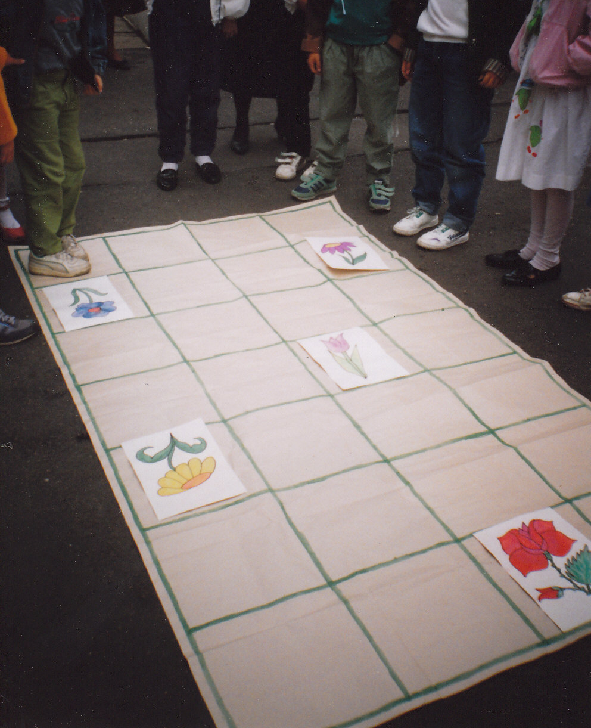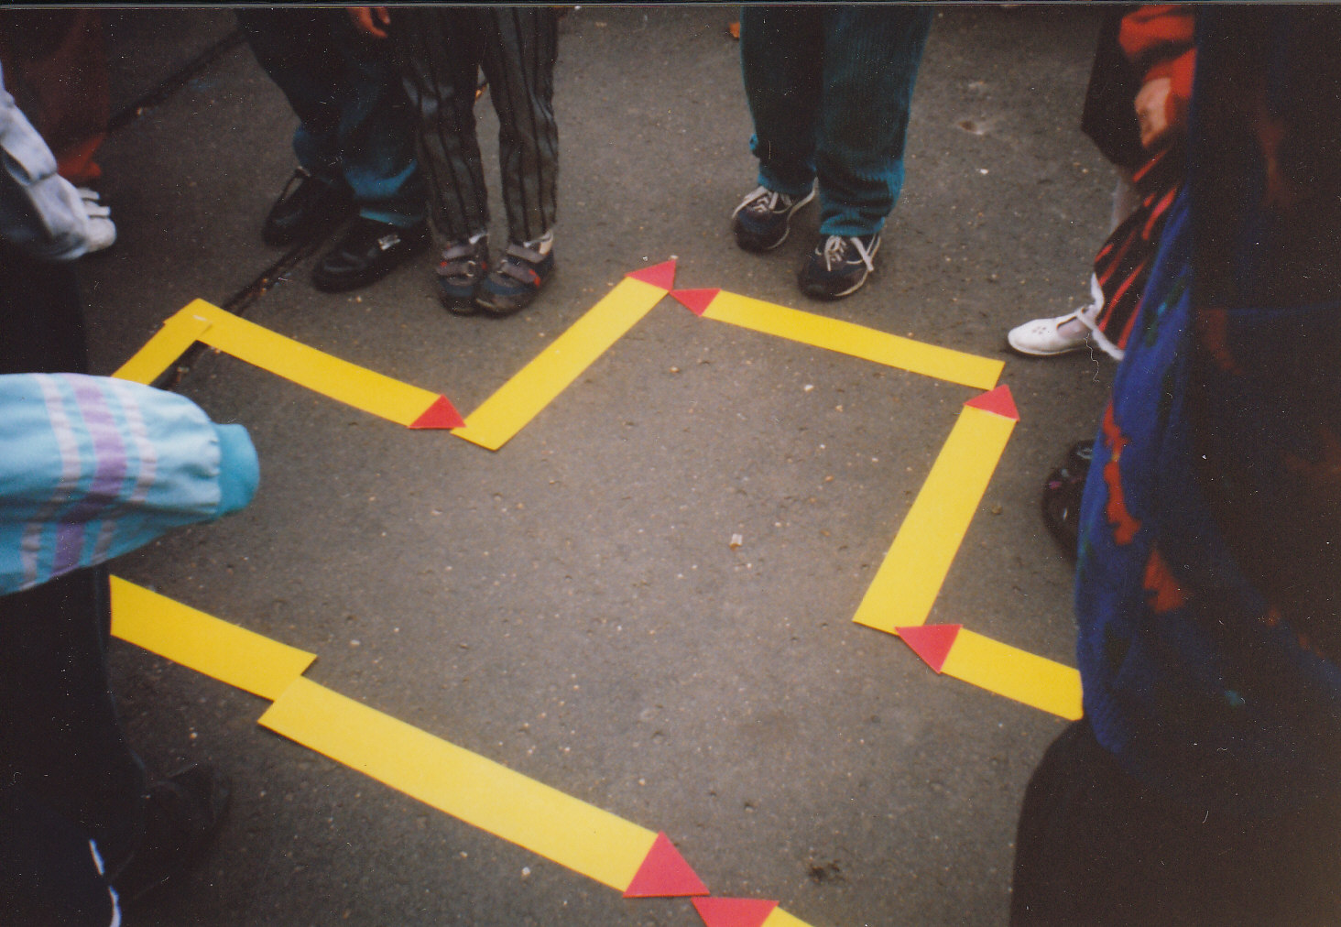
Udvari játékok: a „Teknőc kertje” és a lépések irányát jelző „Gyufalogo”
Hasonló játékötletet láttunk a francia óvodákban is. A játék célja: információszerzés, egy "testvér-óvoda" gyermekeinek megismerése volt. Két óvodai csoport elküldte egymásnak a gyermekek fényképét és a csoportnévsort. A fényképek névvel történő összepárosításában egy irányjáték segített, mivel a fényképek mellé egy egyszerű kódrendszert mellékeltek, minden gyermek esetében mást (pl. előre mutató nyíl 3 lépés, balra fordulás jele stb.). Nagy négyzethálós csomagolópapíron a gyermekek "lelépkedték" a kódokat, így fejtvén meg, hogy melyik képhez melyik keresztnév tartozik. Saját maguk is kitaláltak egy útvonalat ("búvóhelyet a labirintusban"), ezt előbb lépkedéssel, majd LEGO téglácskák tologatásával követték. A feladat nem öncélú volt, az eredmény a távoli pajtás megismerése, eközben az irányok gyakorlása. (A kapcsolattartás ezt követően e-mailen történt, amely szintén nem idegen már a legkisebbek esetében sem!)

Célszerű asztali társasjátékokat, terepjátékokat is készíteni. Iskoláinkban igen népszerű a számítógép bevezetését előkészítő "Teknőc kertje" elnevezésű társasjáték, amelyet a gyermekek a technika foglalkozáson közösen alkotnak: terveznek, vágnak, ragasztanak, festenek. Miért ne készíthetnénk ilyen játékot már akár az óvodában, a kicsik segítségével is? (A teknős fél dióhéjból, a csigák gyurmából, a virágok papírból "születnek meg". A teknős az akadályokat kikerülve jut el a csigához.). A teremben valódi „kertet” is kialakíthatunk: a műanyagpadlóra vagy parkettára színes szigetelőszalaggal rácsot ragasztunk. Az akadályok, a teknős és a csiga ebben a kertben helyezkednek el. A cél az, hogy a teknősbéka (a megszemélyesítő gyermek) – az akadályokat kikerülve – eljusson kedvenc eleségéhez, a csigához. Számtalan variációban játszható, például:

- négyféle utasítással
- kétféle utasítással
- az utasítás ellenkezőjét végrehajtva
- több utasítás megjegyzésével
- a legrövidebb utat választva
- a leghosszabb utat választva

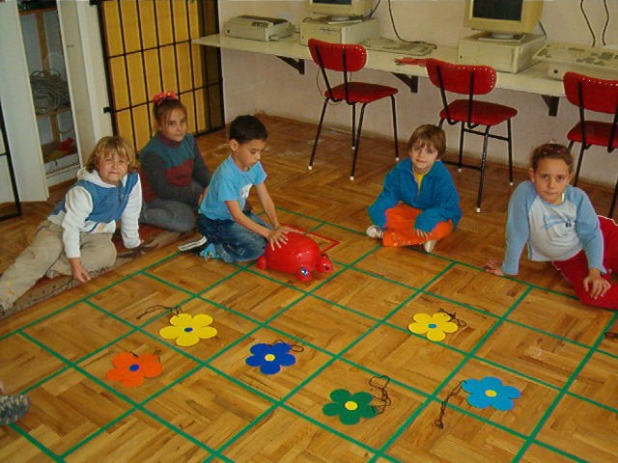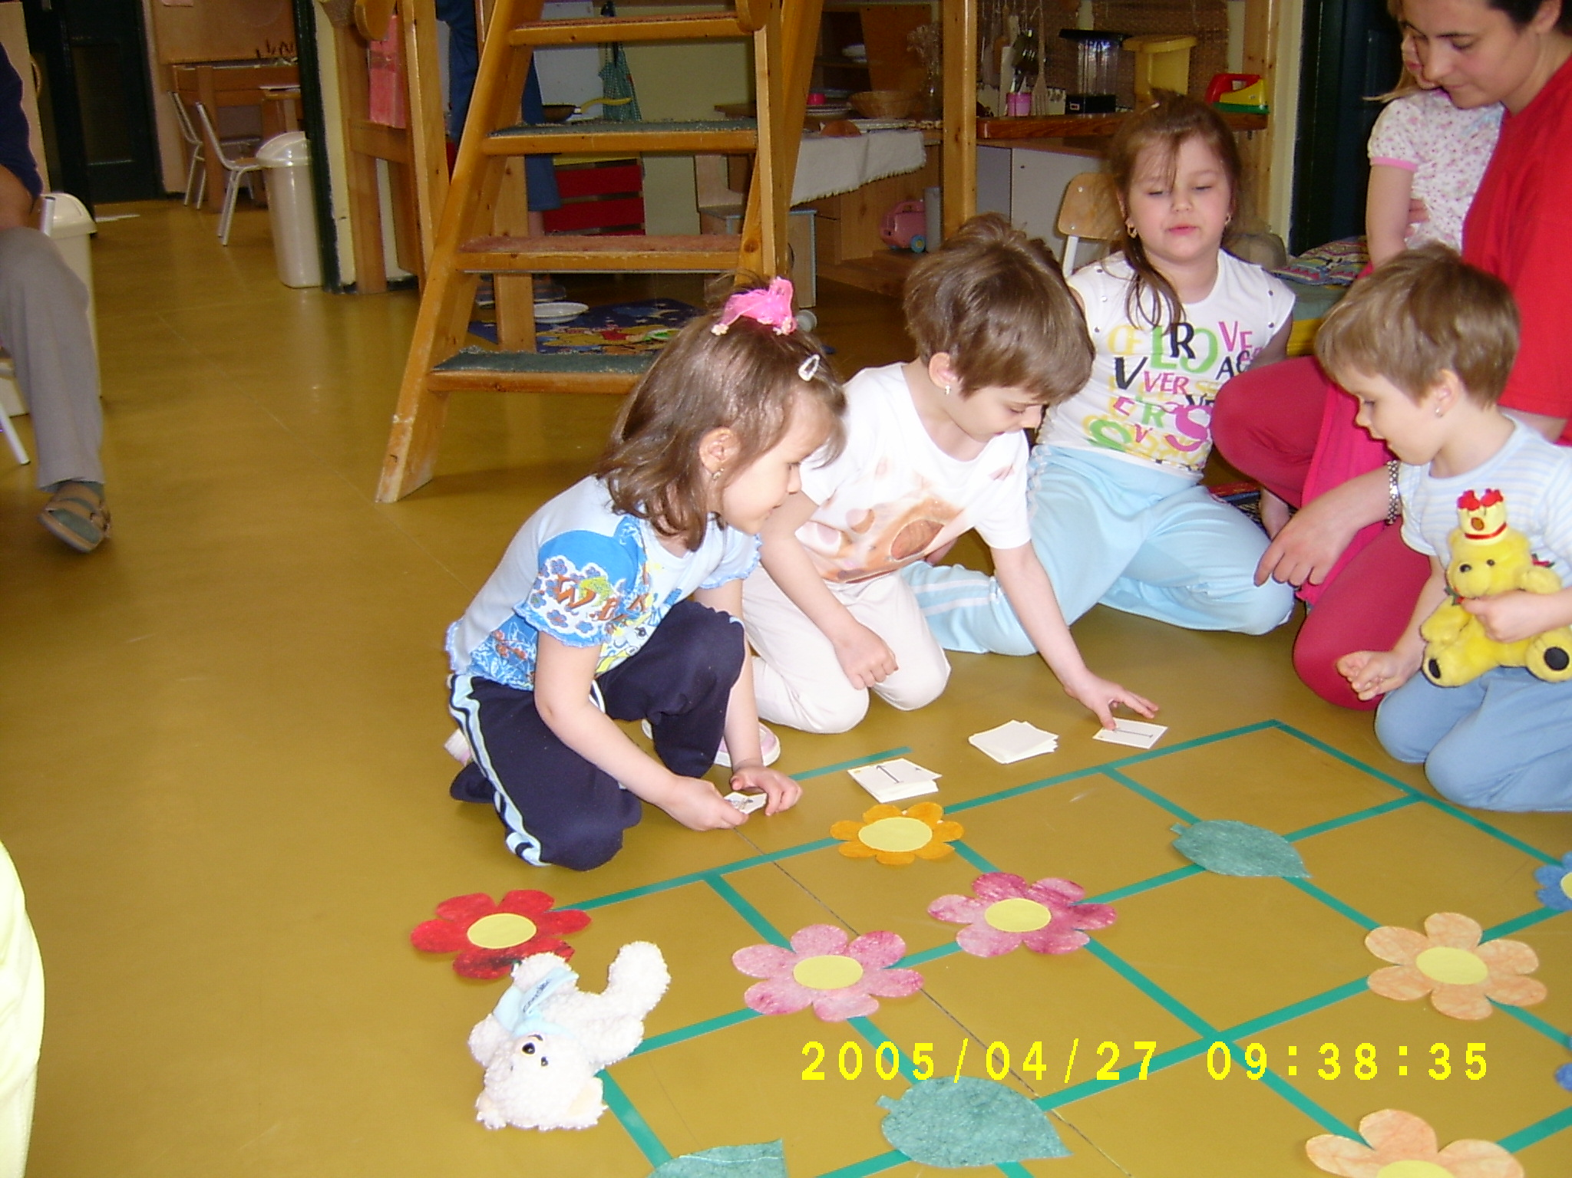

Teknőckert a teremben, az akadályok a négyzetekben vagy a rácsvonalakon is lehetnek

Ezek a feladatok újabb ötleteket adnak az irányok gyakorlásához, a térbeli tájékozódás, koordinációs képesség fejlesztéséhez. Amikor később esetleg a számítógépet is használjuk, a képernyőn megjelenő teknőc helyzetének azonosítása, irányítása, megfelelő alakzat mentén történő elmozgatása, az ehhez szükséges parancsok megadása nem fog gondot okozni a kicsiknek. E játékok fő jellemzője, hogy

- eszközigényük minimális,
- nem tantárgyspecifikusak,
- sok variációjuk létezik,
- előkészítik, ill. hatékonyan segítik a tantárgyi rendszerű oktatást.

Bizonyos feladatok esetében nem mindegy, milyen sorrendben végezzük el a szükséges lépéseket, azaz fontos a sorrend! Az óvodai naposok az asztal megterítésekor variálhatnak, hogy a tányért, a kanalat, a poharat vagy a szalvétát teszik le először az asztalra. A téli reggeli öltözéskor viszont nem mindegy, hogy először a trikót vagy a nagykabátot vesszük-e magunkra: a sorrendnek fontos szerepe van. Ugyanígy egy tea vagy egy étel elkészítése során is lehetnek felcserélhető, illetve szigorúan kötött lépések. Mint e fenti kis mindennapi példák mutatják, egy feladat megoldásakor, azaz algoritmusának megalkotásakor kötött és szabadon eldönthető lépések is lehetnek. A sorrend, a döntések, gondolati elágazások gyakorlására, az algoritmusok megtalálására szép számmal találunk játékos, képességfejlesztő példákat.

Az algoritmusok lejátszása után azok lejegyzetelése is fontos informatikai feladat, amely történhet szöveggel és/vagy rajzzal is. Lényeges mozzanat az algoritmus részekre bontása, finomítása, de csak olyan szintig, hogy még érthető legyen. Ötletes rejtvényfejtés, ha hibás algoritmusokat fejtünk meg, javítunk ki közösen a gyerekekkel. Fordított a helyzet, ha megállapítjuk a teknőc mozgását a már kész leírásból, azaz: Mit rajzolna a teknőc, ha…? típusú parancsokat sorolunk fel vagy játszunk el. A gyermekek és a pedagógusok fantáziája úgyszólván határtalan, ha teknőc-játékokról van szó, a variációk és ötletek kimeríthetetlenek. Idegen nyelvet is tanuló csoport esetében akár a tanult nyelven is elhangozhatnak a parancsok gyakorlásként. Külön öröm, ha a teknőc mozgása – még a képernyőn való megjelenés előtt – valamilyen programozható eszközzel, robottal is megvalósítható: az elmúlt években padlóteknőcök is szerepeltek iskoláinkban, illetve a Lego-Technic készlet segítségével is megépíthetőek.

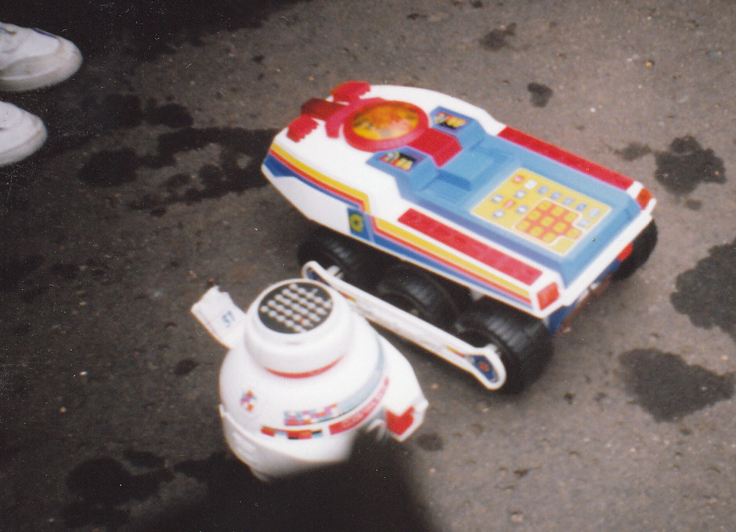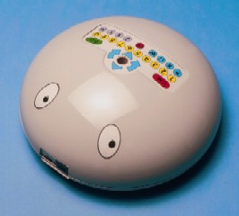

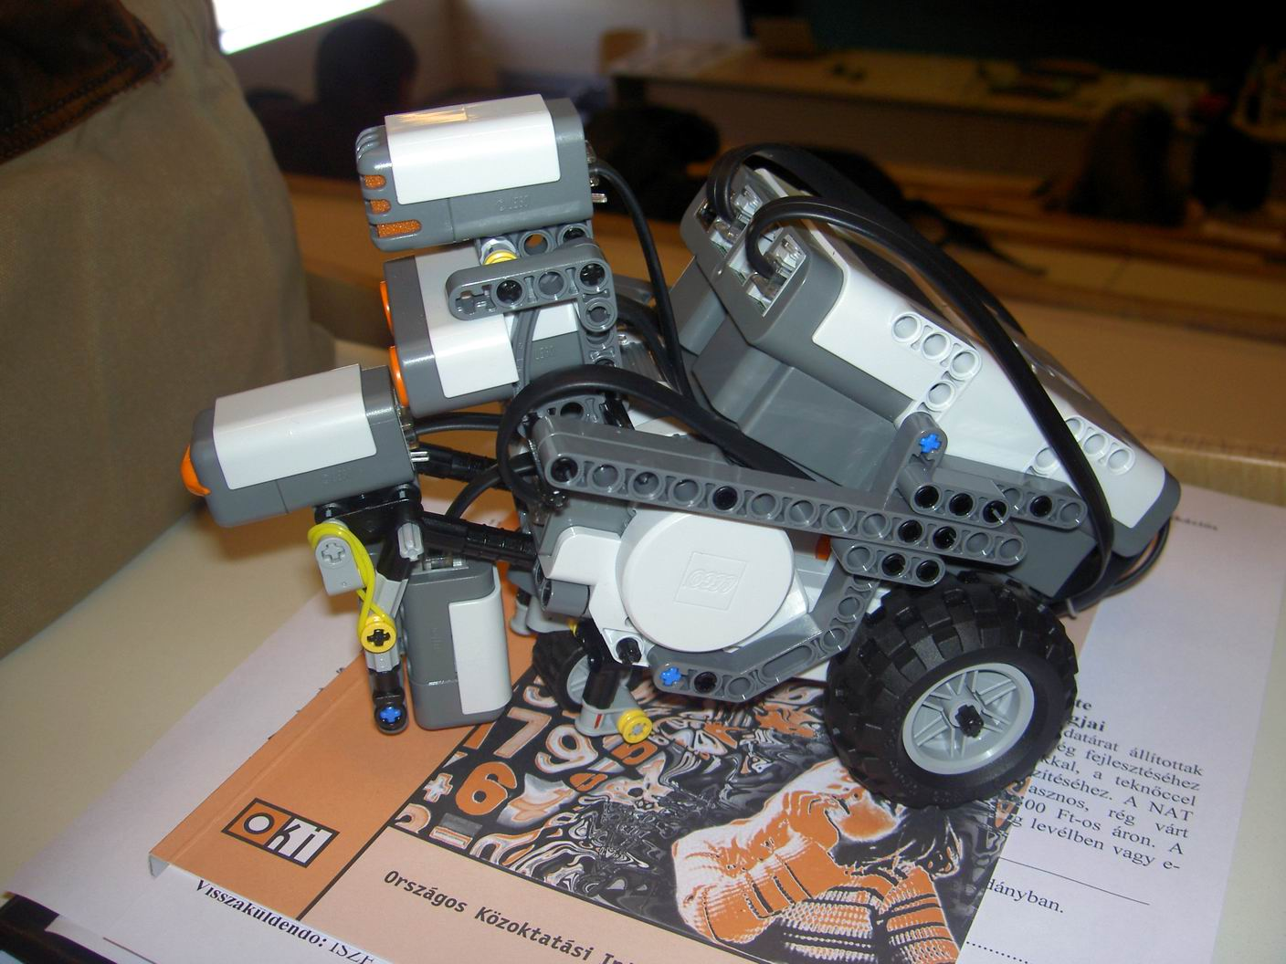
Robotok oktatási célra

Az informatika interdiszciplináris, nem egyetlen tantárgyhoz kötődő jellegét jól szemlélteti a következő játék: amikor a hét esztendős gyermek a padlóteknőccel játszik, parancsot ad, amellyel az eszközt egy adott útvonal bejárására készteti, az útvonalát ezután féllábon ugrálva követi, miközben énekel vagy éppen idegen nyelvű utasításokat ismételget, majd nyilakkal-számokkal (azaz "titkosírással") füzetébe lejegyzeteli a mozgást, ugyanezt a számítógép képernyőjére is elővarázsolja, sőt, egy rövid mesét is mond/ír hozzá, feltehető a kérdés: az iskolában milyen órán vesz részt a gyermek? Matematika, ének, testnevelés, rajz, anyanyelv, idegen nyelv vagy esetleg technika órán? Az informatika tantárgyközi jellege már a kicsik játékos tevékenységekor is szembeötlő. Hiszen az előző cselekvéssor folyamán a gyermek tulajdonképpen algoritmust ismert fel és hajtott végre, ezt a maga módján lejegyzetelte, adatokat kezelt, "alkalmazói problémát oldott meg" egy jól megválasztott eszközzel. Ugyanakkor énekelt (vagy zenélt a teknőccel), rajzolt, tornázott, idegen nyelven beszélt, mesét írt és titkosírást kódolt – a laikus kívülálló szemével nézve.

* * * * *

A Neumann János Számítógéptudományi Társaság (NJSZT) többek közt úgy támogatja a közoktatást, hogy kezdetben a Logo-, majd a Microworlds Szakosztálya 1994 óta minden évben HUNGAROLOGO címmel konferenciát rendez a magyar pedagógusok számára, továbbá lehetőséget biztosít a szakértőknek a kétévente megrendezésre kerülő EUROLOGO konferenciákon történő bemutatkozásra. A tehetséges tanulók számára 1998-tól rendeznek Országos Logo versenyt, amelyen évente rendszeresen 2-3 ezer tanuló méri össze ismereteit a „teknőc parancsolásában”, három fordulóban és négy korcsoportban (3-4. osztály, 5-6. osztály, 7-8. osztály, 9-10. osztály). Az iskolai fordulóban számítógép használata nélkül 3-4 kisebb feladatot (algoritmus- vagy programrészletet, működési vázlatot), majd számítógéppel 2-3 egyszerű feladatot kell megoldani. A második forduló három-négy kisebb, konstruáló, szintetizáló jellegű feladat megalkotását várja. A harmadik forduló már komolyabb, konstruáló, szintetizáló jellegű feladatainak megoldását a résztvevőknek meg kell tervezniük, a programo(ka)t meg kell írniuk. Ezek a versenyek is éltetik a Logot éppúgy, minit a bevezetését és használatát előkészítő és segítő játékokat. És nyugodtan feltételezhetjük, hogy a jót és jól játszó kicsik felnőttkora is színes, változatos lesz!

Maurer rózsák
Farkas Károly:

A Logoról szóló előadásokon időnként azért már a könyökünkön jön ki a kör rajzolás paperti algoritmusa. Unhatjuk azt is, ha valaki négyzetet, házat rajzol, sőt az összetettebb alakzatok alkotása sem hat már ránk az újdonság varázsával.
Próbálok most tehát valami ritkábban látottat rajzolni. Bemutatni ezzel, hogy a "Bontsd a feladatot részekre" Pólya javaslat, a Skinner pedagógiai alapelv (megfelelően kis falatokban adagolás) hatékonyan alkalmazható a "Paradicsomi" mikrovilágban.
Polárkordinátás rendszerben mutatom be a kört és a szinuszfüggvény képét, példázva a „szintonikusabban körrajzolás”-unk algoritmus hasznosságát, majd látványos Maurer rózsákat rajzolok.
1. Bevezetés
Futtatom a mellékletben közölt nyitány nevű eljárást: láthatjuk a Maurer rózsát.
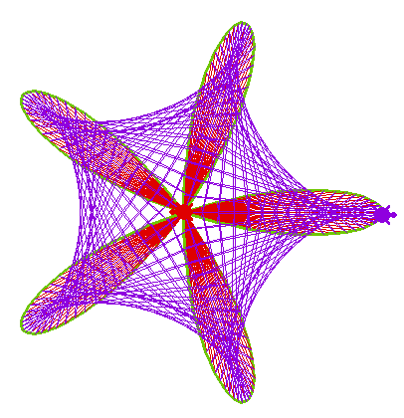
Az ábra tartalmazza a kékkel rajzolt Maurer görbét, annak kifeszítéséhez szolgáló zöld alakzatot, és a zöld alakzatot kitöltő piros sugarakat.
Nézzük meg ugyanezt lassítva, az alakzat genézisének megértéséhez!
2. Poláris koordinátarendszer
Mielőtt elemezzük a Maurer rózsákat, ismételjük a poláris koordinátarendszerről tanultakat!
A következő paranccsal:
fd :d bk 50
Elmegyek d távolságra az origóból, a mozgó szögszárakon, majd visszatérek az origóba.
Ha a vonalhúzás (és visszatérés) után kicsit fordulok, és ezt ismétlem 360-szor
repeat 360 [fd 50 bk 50 rt 1]
360 vonalat húzok. 360-szor valamilyen távolságra megyek és visszatérek a szög függvényében. Jelen esetben ez a távolság konstans volt, 50 teknőclépés. A d=constans(alfa) függvény alatti területet rajzoltam meg.
Amennyiben az origóból történő előrelépés nem letett tollal történik, s csak az előrelépés után teszem le a tollat a rajzlaphoz, és húzok egy lépésnyi vonalat, azaz egy pontot rajzolok, majd felemelt tollal megyek vissza az origóba
repeat 360 [pu fd 50 pd fd 1 pu bk 51 rt 1]
kört rajzolok, amelynek középpontjában „ül” a teknőc.
Milyen alakzatot kapok, ha a d=sin(alfa) függvény szerint haladok?
repeat 360 [make "d 100 * sin heading fd :d bk :d rt 1]
illetve:
repeat 360 [make "d 100 * sin heading pu fd :d pd fd 1 pu bk :d + 1 rt 1]
A szinuszfüggvény polárkoordinátás képe kör, hasonló mint a Paperti kör. (De, nem ugyanolyan!)
Talán nem csak számomra meglepő, hogy a szinusz függvény képe a poláris koordinátarendszerben kör.
Valamiben azért különbözik a paperti kör és a poláris koordinátarendszerben rajzolt szinuszgörbe rajz, a rajzolat finomsága az első esetben egyenletes, a másodikban változó.
A „mégszintonikusabb” körrajzoló eljárásunk (középpontból kinyúlok, pontot rakok, visszajövök, fordulok kicsit) alapelvének alkalmazásával, bármely görbe poláris koordinátás egyenletét kell csak beírnunk :r után, (és célszerűen megválasztani a fordulások mértékét és számát) így máris tudjuk azt a görbét ábrázolni a teknőccel! A görbék rajzolata nem egyenletesen finom (amit „elnyomhatunk” az ismétlések számának fokozásával), de a görbék kialakulása könnyen érthető.
3. Maurer rózsa
Az interneten találunk Maurer rózsák elnevezésű görbéket. Ezek konkáv sokszögek, amelyek burkoló és/vagy vezérgörbéi virágokat - rózsákat alkotnak. A Maurer görbék fonal-feszítések. A Maurer görbéről olvashatjuk, hogy meghatározható, mint egy séta nyomvonala. Ezek után kézenfekvő, hogy Logo nyelven írjuk le ezeket!
Az origóból induljunk,
Az első célpontja sétánknak a [sin n*alfa, alfa] pont, ahol a pont koordinátáit poláris koordinátákkal: távolság és szög, adtuk meg.
A következő szakasz ebből a pontból a [sin n*2alfa, 2alfa] koordinátájú pontba vezet,
A harmadik szakasz a [sin n*3alfa, 3alfa] pontba visz,
és így tovább az eddigiek mintájára választhatjuk meg a következő sarokpontokat!
Látható, hogy a csúcspontok koordinátájának általános alakja [sin n*k, k], ahol k=0*alfa,1*alfa, 2*alfa, 3*alfa, ... , 360*alfa, és alfa pozitív egész szám.
Vagyis a teknőcünk:
első tartózkodási pontja az origo,
a második az a P1 pont, amelynek távolsága az origótól sin :n * :d, és az alapiránnyal (észak) :d szöget bezáró szögszáron van,
a harmadik P2 pont, sin :n * 2 * :d távolságban és 2 * :d szöggel elfordult szögszáron.
Scratch programban ezt megírták, íme így néz ki:
A program a Scratch Logoban már közzétett:
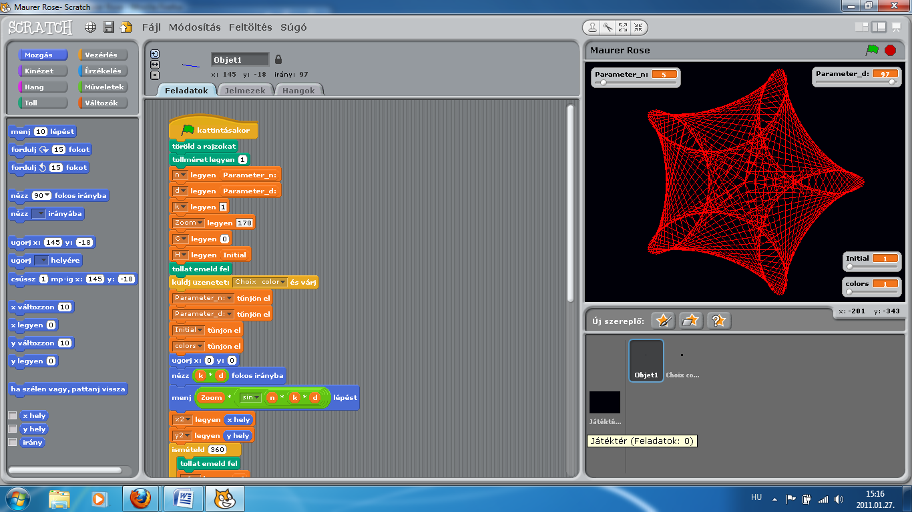
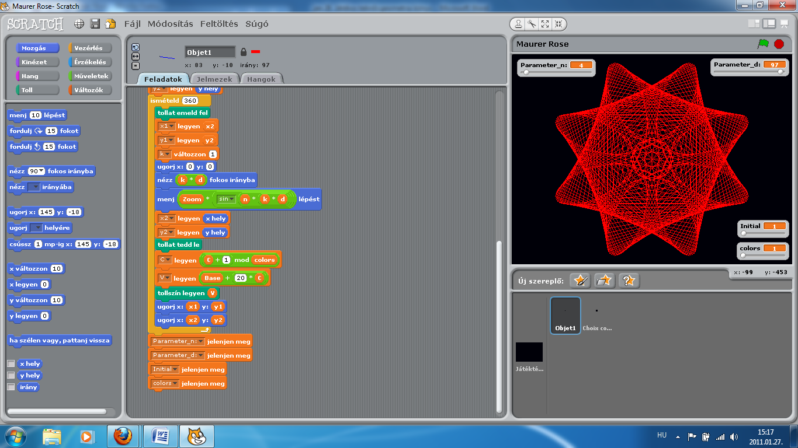
A 2011. januárban letöltött (http://scratch.mit.edu/projects/mathjp/689739) két képernyő tartalom átmásolása közben az n paraméter értékét változtattam ötről négyre.
Vegyük észre, hogy a Scratch program erősen szemlélteti a program struktúráját, szerkezetét, különféle színek és alakzatok felhasználásával.
A Logo-szerűség = egyszerűség
Mi ezt írjuk meg másképpen!
4. Maurer rózsa a Paradicsomban
A sokak által már ismert Paradicsomi mikrovilágban a Maurer görbét rajzoló programot így hoztuk létre:
Legyen két teknőcünk!

to színpadra2
newturtle "Ádám setc 116 st
newturtle "Éva setc 16 st
end
Éva sorba, végig egymás után kijelöli a csúcspontokat. Ádám minden új pont megtalálása után Évához szalad, Ádám mozgásának nyomvonala (Éva tartózkodási pontjainak) összekötése a Maurer rózsa.
to maurer :n :d
make "k 1
Éva, pu
repeat 361 [
Éva, seth remainder :d * :k 360 fd 200 * sin :n * :d * :k
Ádám, towards "Éva fd distance "Éva pd
Éva, bk 200 * sin :n * :d * :k
make "k :k + 1 ]
end
A feszítő görbe (az egymás mellett levő csúcspontokat összekötő vonal) megrajzolására is írhatunk eljárást:
to feszítő :n :d
Ádám, setpensize 3 setc 56 pu
repeat 360 [
Éva, seth :d fd 200 * sin :n * :d
Ádám, towards "Éva fd distance "Éva pd
Éva, bk 200 * sin :n * :d
make "d :d + 1]
Ádám, setpensize 1 setc 116
end
A feszítő görbe (zölddel rajzolt) lehet a Maurer rózsa burkoló görbéje is.
A Scratch programmal is megrajzolt rózsa a mi eljárásunkkal így néz ki:
feszítő 5 97 maurer 5 97
Ha a maurer eljárás hetedik sorába, az ismétlendő lépések végét jelző szögletes zárójel elé beírjuk wait 3 , a sokszög kialakulása jól követhető tempóban látható.
Az egyik Maurer rózsa első négy szakasza

Jól látható a kapcsolatot a Maurer rózsák és a zárt cikloisok között!
Vessük össze a Logo programkódot például a MAPLE kóddal!
with(plots) :
n:=7:d:=29:
Rose:=plot(sin(n*t),t=0..2*Pi,coords=polar,thickness=2):
K:=360:
for k from 0 to K do k1:=k*d*Pi/180:k2:=(k+1)*d*Pi/180:
Point[k]:=pointplot([sin(n*k1),k1],coords=polar,color=blue):
Maurer_rose[k]:=listplot([[sin(n*k1),k1],[sin(n*k2),k2]],coords=polar,color=blue):od:
Maurer_rose:=display(seq(Maurer_rose[k],k=0..K)):
Point:=display(seq(Point[k],k=0..K)):
display(Rose,Point,Maurer_rose);
5. Melléklet
A rajzok és bemutató készítéséhez alkalmazott programkódok:
to nyitány
cg demony 5 91
end

to demony :n :d
;n fázisok száma, d rajzolat finomsága
;maurer2, amit Éva végigjár
maurer2ny :n :d
;feszítő, Éva utjának burkológörbéje
feszítőny :n :d
;maurer, Ádám útvonala, a Maurer görbe
maurerny :n :d
end

to maurerny :n :d
make "k 1
Éva, pu
repeat 181 [
Éva, seth remainder :d * :k 360 fd 200 * sin :n * :d * :k
Ádám, towards "Éva fd distance "Éva pd
Éva, bk 200 * sin :n * :d * :k
make "k :k + 1 ]
end

to feszítőny :n :d
Ádám, setpensize 3 setc 56 pu
repeat 180 [
Éva, seth :d fd 200 * sin :n * :d
Ádám, towards "Éva fd distance "Éva pd
Éva, bk 200 * sin :n * :d
make "d :d + 1]
Ádám, setpensize 1 setc 116
end

to maurer2ny :n :d
pd
make "k 1
repeat 181 [
Éva, seth remainder :d * :k 360 fd 200 * sin :n * :d * :k
Éva, bk 200 * sin :n * :d * :k
make "k :k + 1]
end

to vezérpontok
pd
make "k 1
repeat 361 [
Éva, seth remainder d * :k 360 fd 200 * sin n * d * :k
Éva, bk 200 * sin n * d * :k
make "k :k + 1]
end

to mrózsa
make "k 1
Éva, pu
repeat 361 [
Éva, seth remainder d * :k 360 fd 200 * sin n * d * :k
Ádám, towards "Éva fd distance "Éva pd
Éva, bk 200 * sin n * d * :k
make "k :k + 1 ]
end

to maurer2 :n :d
pd
make "k 1
repeat 361 [
Éva, seth remainder :d * :k 360 fd 200 * sin :n * :d * :k
Éva, bk 200 * sin :n * :d * :k
make "k :k + 1]
end

to mau :n :d
feszítő :n :d
maurer :n :d
end

to demo :n :d
;n fázisok száma, d rajzolat finomsága
;maurer2, amit Éva végigjár
maurer2 :n :d
;feszítő, Éva utjának burkológörbéje
feszítő :n :d
;maurer, Ádám útvonala, a Maurer görbe
maurer :n :d
end

Elica home page, http://www.elica.net
TARGET project site, http://www.reachyourtarget.org/
http://www.elica.net/site/ museum/Dalest/dalest.html
InnoMathEd project site, http://www.math.uni-augsburg.de/prof/dida/innomath
Virtual Mechanics collection, http://www.youtube.com/elicateam#g/c/6534E936D46257BF
Logo Tree Project. http://www.elica.net/download/papers/LogoTreeProject.pdf
ElicaTeam’s YouTube Channel, http://www.youtube.com/elicateam
Film “Ellipses…”, http://www.youtube.com/watch?v=1v5Aqo6PaFw
SRANDBEEST, http://www.strandbeest.com

