Registration for Óbuda University O365
(somebody@stud.uni-obuda.hu email address + MS Teams access)
- go to http://o365.uni-obuda.hu/
Unfortunatelly, this webpage is mostly in Hungarian.
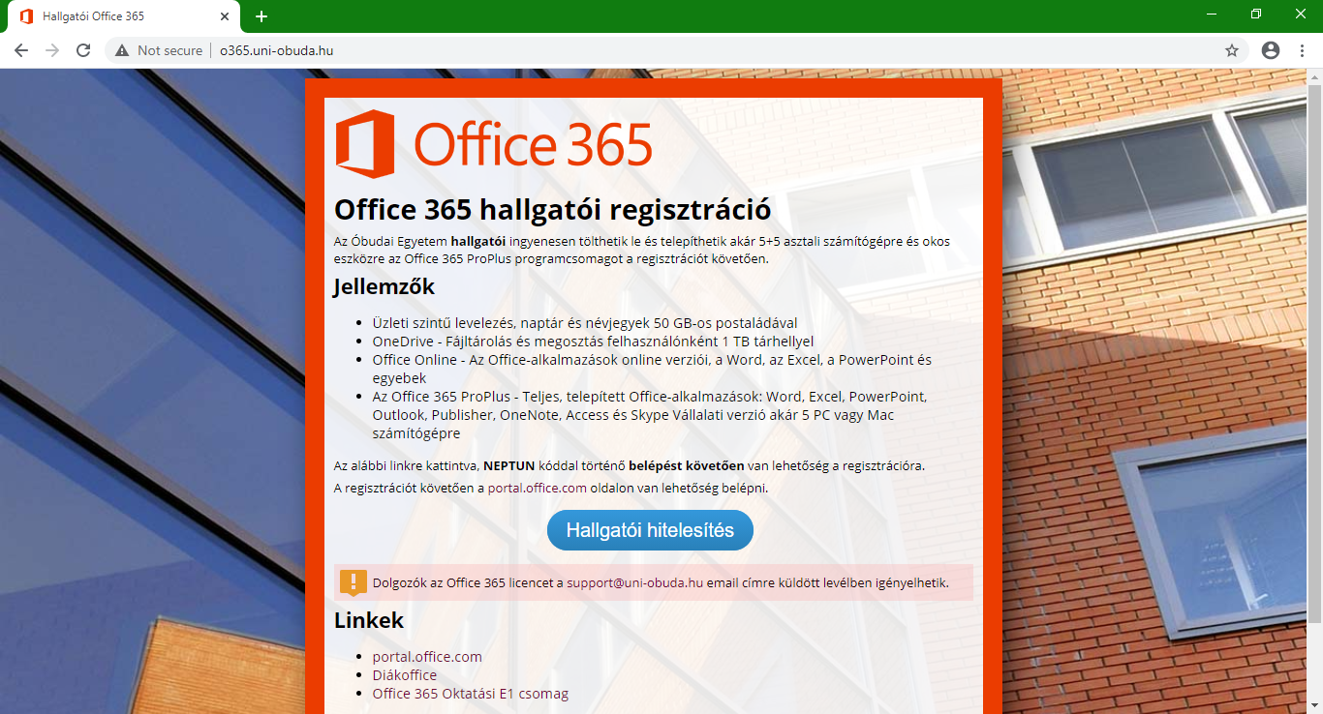
- Click on the „Hallgatói Hitelesítés” button („Student Authentication”)
- Then the one-time login page shows up. Here, you should enter your NEPTUN credentials. You can change the language of the page at the bottom.
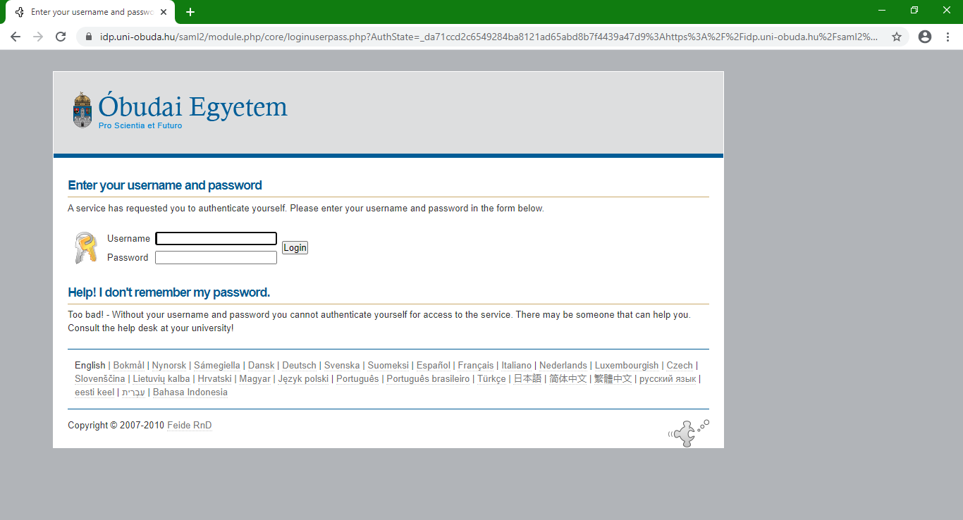
- Then you should add permission to the page to transmit your SSO code to the O365 page. Tick the checkbox „Remember” and then click the button „Yes, continue”
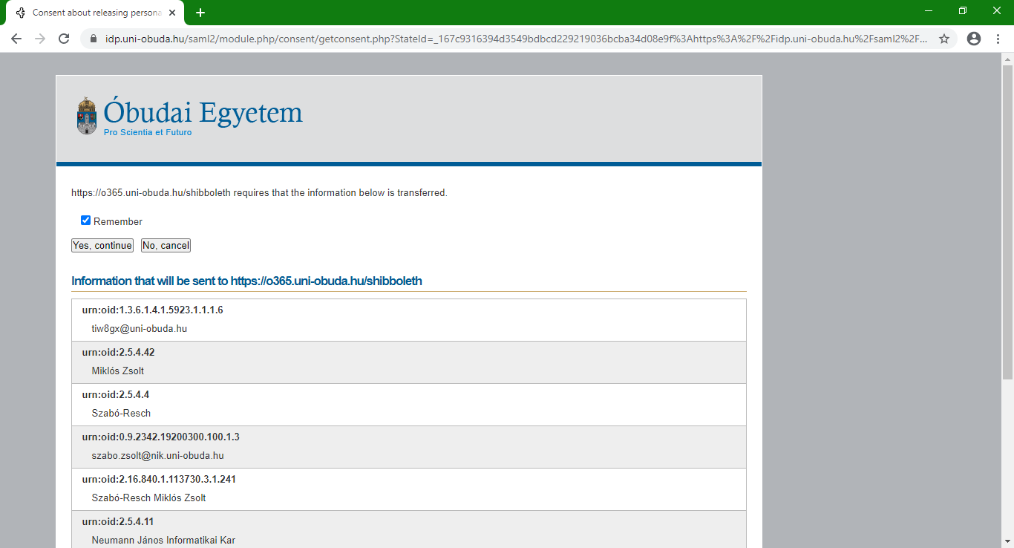
- Then you have to enter your username (this will be your email address, as someUserName@stud.uni-obuda.hu) and your password (8-16 characters, minimum one capital letter, minimum one lowercase letter, minimum one number; cannot contain common words/names). Also tick the checkbox to accept the usage terms. Then click on „Regisztráció” = „Registration”
