Számítógép kategóriák/jellemző számítógép családok illetve alapul választott processzor-típusok
fejlődése

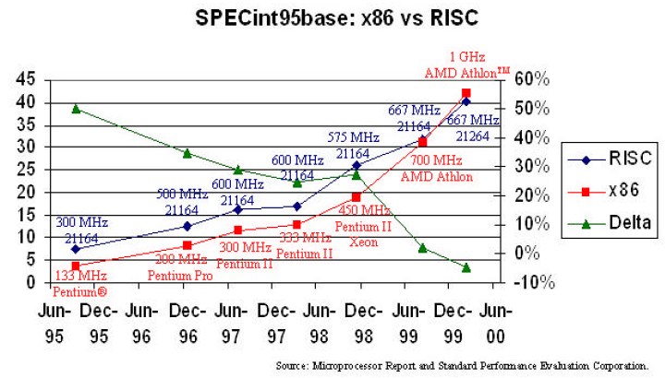

SPEC benchmarks
(see also Table 1)

Intended for compute intensive charasteristic applications, separately for FX- and FP-jobs.
It reflects the performance of the processor, memory and compiler.
The set of selected FX/FP jobs is called the CINT/CFP benchmark suit.
CINT suit: mostly C (C++) programs
CFP suit: mostly FORTRAN programs

Principle of measurement
The SPECmark figures are obtained while comparing the run times on both the reference model and the test model.

Calculation of the SPECmarks

The SPECmark is the geometric mean of the speed up values measured for each of the benchmark programs.

SPECint89/92/95/2000 = R* n$\sqrt{\frac{t_{\text{int}1r}}{t_{\text{int}1t}}∗−−−\frac{t_{\text{int}\text{nr}}}{t_{\text{int}\text{nt}}}}$
SPECfp89/92/95/2000 = R* m$\sqrt{\frac{t_{\text{fp}1r}}{t_{\text{fp}1t}}∗−−−\frac{t_{\text{fpmr}}}{t_{\text{fpmt}}}}$

R: is the reference value, it is 1 for the SPEC89/92/95 benchmarks and 100 for the SPEC2000 figures.

SPEC benchmarks

Peak values Base values
Measured Measured
after tuning the compiler under prescribed settings (since
SPEC95)
Designations:
SPECint89/92/95/2000 SPECint_base 95/2000
SPECfp89/92/95/2000 SPECfp_base 95/2000

For an example see Annex.

Converting SPECmarks
SPEC95 ≅ $\frac{1}{\text{40}}$ SPEC92
SPEC2000 ≅ 10 SPECint95

Successive benchmark suits include usually:
- more benchmark programs,
- more complex benchmark programs,
- more heavy memory usage.

 | Interpretation |  | Number of benchmark processors |  | Ref. model | Processor | fc  MHz | L2  MB | Reference value
 | Peak | Base | CINT | CFT
SPEC89 |  | - | 4 | 6 | VAX 11/780¹ | - | 5 | - | 1
SPEC92 |  | - | 6 | 14 | VAX 11/780¹ | - | 5 | - | 1
SPEC95 |  |  | 8 | 10 | SPARCstation 10/40 | SuperSPARC I | 40 | - | 1
SPEC2000 |  |  | 12 | 14 | Sun Ultra 5_10 | SuperSPARC II_{i} | 300 |  | 100

¹ VAX 11/780: 1 MIPS machine

Table1: Main features of the SPEC benchmarks

Figure 4: Historical increase in the clock frequency of Intel x86 processors

Figure 5: Increase in the efficiency of the microarchitecture of Intel’s x86 line of processors

Dissipation figures of Intel cores related to the die area.

Figure: The efficiency of PIII and P4 cores

Figure c1: Reduction of DRAM access times in x86-based PCs.

Figure c2: The increase of memory latency in x86-based PCs.

